Long-term change in the burden of anisakid nematode parasites for marine mammal hosts

Dissertation Proposal

Natalie Mastick

School of Aquatic and Fishery Sciences

University of Washington

February 19, 2021

### Introduction

The oceans are changing. Assessing how taxa respond to global change is the purpose of countless studies, and as a result much is known about how different species respond to a changing environment. However, less attention is paid to species that are not free living—those that depend on other species to survive (Dunn et al. 2009, Carlson et al. 2017). Parasites are dependent on their hosts in such a way, and parasites with complex life cycles depend on multiple hosts (Combes 2001). Changes like biodiversity loss and climate change are predicted to have varying impacts on parasite species depending on the range and the life history strategies of the parasite and their hosts (Carlson et al. 2017; [Harvell et al. 2002; Wood and Lafferty 2013; Salkeld et al. 2013; Rohr et al. 2020)](https://paperpile.com/c/kiyr7b/Cofu+gtLT+0RzN+cFbb). This leaves parasites susceptible to variable responses to a changing environment as some host species increase while others decrease, and multi-host parasites are particularly vulnerable [(Harvell et al. 2002; Rohr et al. 2011](https://paperpile.com/c/kiyr7b/Cofu+8RmI); Carlson et al. 2017; Welicky et al. *in review*). How is long-term global change shaping the fate of parasites, and what does that mean for their hosts?

One interesting case is that of marine mammal hosts. There has also been an observed increase in infectious disease in marine mammals [(Ward and Lafferty 2004; Gulland and Hall 2007; Van Bressem et al. 2009)](https://paperpile.com/c/kiyr7b/DDpM+RrYy+710b). Some parasites that infect marine mammals are generalists, meaning they infect many marine mammal definitive (final) host species [(Marcogliese 2002; Klimpel and Palm 2011)](https://paperpile.com/c/kiyr7b/6ecF). In directly transmitted parasites, if their necessary host species are available, the parasites are positioned to persist (Carlson et al. 2017). Yet some generalist parasites have complex, multi-host life cycles that leave them more vulnerable to extinction in a changing climate due to a reliance on a greater number of hosts to complete their development and reproduction [(Harvell et al. 2002](https://paperpile.com/c/kiyr7b/Cofu); Carlson et al. 2017). This combination of generalism and complex life cycles leaves these parasites at risk to an uncertain future. However, if the appropriate hosts persist in a changing climate, their parasites could too. In the case of marine mammals, parasites may even increase as marine mammal populations increase, becoming more prevalent in the marine environment and increasing the risk of infection to less abundant hosts.

|  |  |
| --- | --- |
| **Term** | **Definition** (from Bush et al. 1997) |
| Abundance | The number of individuals of a particular parasite in/on a single host regardless of whether or not the host is infected. |
| Prevalence | The presence or absence of parasites in a sample of hosts, used to classify hosts into infected and uninfected categories. |
| Intensity | The number of individuals of a particular parasite species in a single infected host (also referred to as *parasite load*). |
| Mean intensity | The average intensity of a species of parasite among the infected members of a particular host species. |

Table 1. Key terms in parasite ecology, defined by [(Bush et al. 1997)](https://paperpile.com/c/kiyr7b/GvMd), that will be used throughout this proposal.

Marine mammals are important hosts to consider because they have immense potential to harbor and spread parasites to other hosts throughout their ranges. Marine mammals are distributed throughout the world’s oceans, and many migrate large distances (e.g. Northern elephant seals (*Mirounga angustirostris*), humpback whales (*Megaptera novaeangliae*); Stewart et al. 1995; Clapham 2018) typically between foraging and birthing grounds. In multi-host life cycle parasites with eggs dispersed through defecation, broad ranges increase the probability of parasites being deposited somewhere that they can survive and infect the correct hosts. Additionally, some marine mammals are social, which can lead to direct transmission of parasites [(Balbuena et al. 1995; Mann et al. 2000; Gaydos et al. 2006, Lavigne and Schmitz 1990)](https://paperpile.com/c/kiyr7b/LfOj). Many delphinids form pods and frequently have close interactions with conspecifics, and some pinnipeds are known to haul out and breed in dense aggregations (Johnson and Norris 1986, Mann et al. 2000, Cassini 1999). Even in less social marine mammal species, like large baleen whales, socialization still occurs while nursing dependent young or mating (Tyack 1986), both of which can result in direct parasite transmission (e.g. direct transmission of ectoparasitic whale lice, Balbuena et al. 1995). Social behavior in marine mammals therefore contributes to the spread of parasites and infectious disease, which could increase with increasing animal density (Lavigne and Schmitz 1990). Finally, marine mammals are long-lived (Musick 1999, Mann et al. 2000, Berta 2020), which increases the potential for long-term parasite infections and continuous transmission to the surrounding environment and vulnerable hosts. With increases in marine mammal abundance resulting from regulation of harvest, there is potential for parasitism to increase both within individuals and populations.

Historically, many marine mammal populations were depleted due to unregulated anthropogenic harvest. While regulations have been enacted on both national (Marine Mammal Protection Act, 1972) and international (International Whaling Commission’s moratorium on commercial whaling, 1986) level, many marine mammal species have failed to recover [(Lotze et al. 2011; Roman et al. 2013; Magera et al. 2013)](https://paperpile.com/c/kiyr7b/lOWZ+QIHX+LIhD). Some species have increased to carrying capacity (e.g. grey seals (*Halichoerus grypus*), and California sea lions (*Zalophus californianus*)) and others are near the brink of extinction (e.g. southern resident killer whales (*Orcinus orca*), North Atlantic right whales (*Eubalaena glacialis*)), largely based on the extent and timing of their prior exploitation [(Lotze et al. 2011; Knowlton et al. 2012; Roman et al. 2013; Magera et al. 2013](https://paperpile.com/c/kiyr7b/lOWZ+LIhD+QIHX+GYQ5); NOAA 2016). The observed lack of recovery in some species is partially due the continuation of activities that were not regulated by these pieces of legislation, including contamination, ship strikes, bycatch, and entanglement [(Laist et al. 2001; Cassoff et al. 2011; Trumble et al. 2013)](https://paperpile.com/c/kiyr7b/nnWl+BwZb+Ut3F). Due to persistent stressors, there are currently 14 populations of marine mammals listed as endangered under the U.S. Endangered Species Act (ESA), and 20 listed as endangered or critically endangered by the International Union for Conservation of Nature (IUCN) Red List. However, of the marine mammal species globally with enough data to detect a trend, 42% are increasing; overall, they have recovered to 61% of their historical abundance [(Magera et al. 2013)](https://paperpile.com/c/kiyr7b/LIhD). Increases in the total number of marine mammal hosts increases the potential for parasite transmission to both the marine mammal populations that are recovering and those that are not.

Despite the potential increase in risk, parasitism in marine mammals remains understudied. This is largely due to the difficulty in assessing a marine mammal for parasites. Parasitological examinations are limited to analyzing difficult-to-obtain fecal samples from wild animals or necropsies of deceased animals, the latter being unrepresentative of a healthy wild individual [(Dailey and Stroud 1978; Aguilar and Borrell 1994; Ten Doeschate et al. 2017; Hermosilla et al. 2018)](https://paperpile.com/c/kiyr7b/iG3m+T6KP+KXxd+AlJV). Because of the difficulty in assessing parasite infections in wild, living animals, there is a deficit of knowledge on parasitism in wild marine mammals, including the prevalence and intensity of infections (Table 1). Through necropsies, we know that marine mammals are known to host many parasites [(Dailey and Stroud 1978; Dailey 1980; Stroud and Roffe 1979)](https://paperpile.com/c/kiyr7b/T6KP+cbU6+6Nrj+3AFH). Parasites have been found throughout marine mammal bodies, including in the blowhole, sinus cavities, lungs, stomach and intestine, mammary tissue and urogenital system, and auditory organ, and can cause mild to severe health problems [(Dailey 1980; Dailey 2001)](https://paperpile.com/c/kiyr7b/cbU6+IfxJ). Parasitic intestinal nematodes alone can deprive their hosts of energy, form granulomas in the stomach lining, cause ulceration, result in perforations in the stomach leading to peritonitis, and hemorrhaging from damage to the gastric mucosa [(Dailey and Stroud 1978; Stroud and Roffe 1979; van Beurden et al. 2015)](https://paperpile.com/c/kiyr7b/6Nrj+BjkD+3AFH). The parasites that infect other parts of the body can similarly result in disease and mortality, inducing an energetic cost to the host.

One parasite family frequently found in the intestines of marine mammals are nematodes (i.e., roundworms) in the family Anisakidae. There are three prominent genuses found in marine mammals: *Anisakis* spp., *Pseudoterranova* spp., and *Contracaecum* spp. Worms in each genus have complex life cycles that require both intermediate and paratenic (intermediate hosts that are not essential for the parasite’s development) hosts to disperse the parasites to their definitive hosts via trophic transmission [(McClelland 2005; Klimpel and Rückert 2005; Palm and Klimpel 2007; Klimpel and Palm 2011)](https://paperpile.com/c/kiyr7b/6ecF+9TXZ+uzXU+2U2b). The intermediate and paratenic hosts are invertebrates and fish, though the definitive hosts differ by parasite species (Figure 1).

*Anisakis* spp. nematodes infect cetaceans as their definitive hosts, though can accidentally infect pinnipeds as well [(Køie et al. 1995](https://paperpile.com/c/kiyr7b/nnSF); [Klimpel and Palm 2011)](https://paperpile.com/c/kiyr7b/6ecF). The *Anisakis* spp. life cycles involve four larval phases (L1-L4) and takes place mainly in the pelagic environment [(Klimpel and Palm 2011)](https://paperpile.com/c/kiyr7b/6ecF). It starts when an egg is deposited into the ocean through a cetacean’s scat. L1 through L3 take place inside of the egg in the ocean. L3 are then eaten by the first intermediate host, a pelagic crustacean, which breaks the larva’s cuticle and the L3 penetrates the intestinal tract into the haemocoel [(Køie et al. 1995)](https://paperpile.com/c/kiyr7b/nnSF). The crustacean is then eaten by the second intermediate host, which can be a larger copepod, euphausiid, or small fish. Larger fish or copepods can serve as paratenic hosts by predating on the second intermediate hosts, transferring the larvae up the food web without further development. Cetaceans become infected by consuming the second or paratenic host, at which time the larvae develop into the adult L4 stage and reproduce within the digestive tract. 34 species of cetaceans are known to harbor *Anisakis* spp., including species from the families Delphinidae, Phocoenidae, Monodontidae, Pontoporiidae, Ziphiidae, Kogiidae, Physeteridae, Neobalaenidae, and Balaenopteridae [(Mattiucci and Nascetti 2007; Klimpel and Palm 2011)](https://paperpile.com/c/kiyr7b/DAXs+6ecF).

*Pseudoterranova* spp. are known to infect 10 pinniped species as their final hosts, and their life cycle is mainly benthic [(Klimpel and Palm 2011)](https://paperpile.com/c/kiyr7b/6ecF). Like the *Anisakis* spp. life cycle, the *Pseudoterranova* spp. life cycle begins with eggs defecated by an infected pinniped. The egg then sinks to the seafloor and develops through L1-L2, and hatches to L3. L3 then are eaten by their first intermediate host, a benthic crustacean, in which the larvae penetrate the digestive tract and enter the haemocoel. The invertebrate is then consumed by a benthic macroinvertebrate, which acts as the second intermediate host [(Anderson 2000; McClelland 2002; 2005)](https://paperpile.com/c/kiyr7b/bxUa+9TXZ+4b5F). Like *Anisakis*spp., *Pseudoterranova* spp. can then be transferred to paratenic hosts, this typically occurring in two steps. The first secondary host is generally a benthic teleost juvenile fish, which is then consumed by a piscivorous paratenic host before ultimately reaching their final pinniped host [(Palm 1999; Anderson 2000; McClelland 2002; 2005)](https://paperpile.com/c/kiyr7b/WzBr+bxUa+9TXZ+4b5F). There the worm embeds itself in the gastric mucosa and develops into its L4 stage to reproduce [(Klimpel and Palm 2011)](https://paperpile.com/c/kiyr7b/6ecF).

*Contracaecum* spp. infect pinnipeds or sea birds, and their life cycle spans the benthic and the pelagic. Like the other two species, eggs are released into the ocean in their definitive host’s scat. The larvae then develop to L3 stage and are consumed by a benthic or pelagic invertebrate as a first intermediate host, followed by a dielly migrating fish as a paratenic host [(Klöser et al. 1992; Køie and Fagerholm 1995; Køie et al. 1995)](https://paperpile.com/c/kiyr7b/nnSF+w9n9+gbKr). They are known to infect 12 species of pinniped hosts, as well as several seabird species [(Klimpel and Palm 2011)](https://paperpile.com/c/kiyr7b/6ecF).

Once inside their marine mammal definitive host, anisakids can cause both direct and indirect fitness costs. After being consumed in an intermediate host the nematodes penetrate the gastric mucosa to reproduce, inhabiting the stomach compartments, within the gastric lumen, or attached to the gastric or stomach wall mucosa [(Geraci and St. Aubin; Margolis and Dailey 1972; Iñiguez et al. 2011)](https://paperpile.com/c/kiyr7b/4RTx+up1h+Bzrw). Anisakids have been associated with eosinophilic and granulomatous inflammation and areas of necrosis in the gastric mucosa [(Motta et al. 2008)](https://paperpile.com/c/kiyr7b/wl18). In penetrating the mucosa, anisakids can cause gastritis and ulceration of the mucosa and submucosa [(Cattan et al. 1976](https://paperpile.com/c/kiyr7b/c6RS); Moeller 2001). Individuals cluster in groups of 50-100 with their anterior ends embedded in ulcers up to 6 cm in diameter [(Geraci and St. Aubin; Motta et al. 2008](https://paperpile.com/c/kiyr7b/4RTx+wl18); Audicana et al. 2003). The ulcers may be acute and hemorrhagic, or chronic, and can be associated with edema [(Motta et al. 2008; Würsig et al. 2009)](https://paperpile.com/c/kiyr7b/HweG+wl18). In stranded cetaceans off the coast of Brazil, 6/8 of animals with anisakid infections exhibited chronic lymphoplasmocytic gastritis [(Motta et al. 2008)](https://paperpile.com/c/kiyr7b/wl18). In severe infections, the perforations of the stomach wall can cause peritonitis and ultimately lead to hemorrhaging and death [(Dailey and Stroud 1978; Stroud and Roffe 1979; van Beurden et al. 2015)](https://paperpile.com/c/kiyr7b/AC1I+3AFH+BjkD). At the very least, anisakids are an energy sink, sequestering nutrients away from their hosts, though to date the proportion of host energy taken by parasites is unknown. The impacts of parasitism may be more severe in conjunction with other stressors.

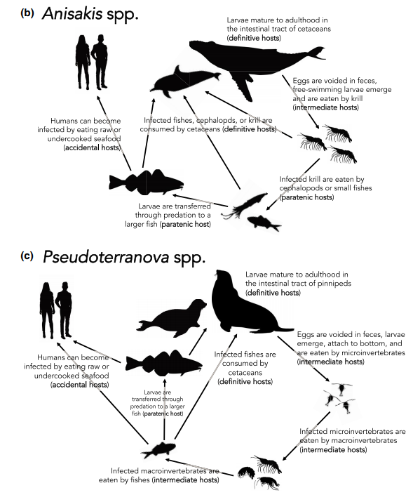

Figure 1: From Fiorenza et al. (2020). General life cycle of *Anisakis* spp. and *Pseudoterranova* spp. nematodes. *Anisakis* spp. use cetaceans as definitive hosts, *Pseudoterranova* spp. infect pinnipeds, and *Contracaecum* spp. infect pinnipeds and sea birds. Though these are their targeted hosts, anisakid nematodes can accidentally end up in the wrong marine mammal hosts and have pathogenic effects, meaning anisakids can impact all marine mammals.

Severity of anisakid infections can be linked to other stressors, including anthropogenic stressors and co-infections of parasites. The consequences of a parasite acting in conjunction with other environmental factors was apparent in Cordova, Alaska in the winter 1995-1996 during a large sea otter mortality event [(Margolis et al. 1997](https://paperpile.com/c/kiyr7b/Yf8F); Ballachey et al. 2002). Sea otters (*Enhydra lutris kenyoni*) are not definitive hosts for *Pseudoterranova decipiens*, yet when nine of the stranded animals were necropsied, they all harbored the parasite. In fact, *P. decipiens* was associated with the most severe pathology, including perforations of the intestinal tract, leading to the death of all nine sea otters [(Margolis et al. 1997](https://paperpile.com/c/kiyr7b/Yf8F); Ballachey et al. 2002). However, in some areas, sea otters have appeared perfectly healthy while harboring *P. decipiens*. In concert with additional stressors the sea otters were facing, the impact of the nematode load resulted in mortality (Ballachey et al. 2002). Similarly, in St Lawrence Estuary, necropsy findings of beluga whales (*Delphinapterus leucas*) have shown that *Anisakis* sp. parasitic nematodes can cause severe pathology and death [(Lair et al. 2016)](https://paperpile.com/c/kiyr7b/IHnu). Belugas face several additional stressors in this area, including PCB contamination, which is known to reduce immunosuppression in a host, potentially increasing the severity of anisakid pathology [(Lair et al. 2016)](https://paperpile.com/c/kiyr7b/IHnu). These case studies show the effect that additional stressors play on the impact of parasitism on a host. Parasite load as well as environmental context inform whether parasitism will have benign or severe impacts on an individual or a population [(Combes 2001)](https://paperpile.com/c/kiyr7b/GvMd+Iqxv). What does this mean for the health of marine mammal host species that are subject to other stressors, especially if anisakids are increasing?

A recent study showed that globally, there has been an increase in *Anisakis* spp. abundance in fish and squid intermediate hosts [(Fiorenza et al. 2020)](https://paperpile.com/c/kiyr7b/8fdd). In this study, Fiorenza *et al.* conducted a meta-analysis of records of *Anisakis* and *Pseudoterranova* spp. in fish and squid host species published in peer-reviewed literature from 1967 to 2017. The data were spatially biased—many of the samples were collected from the Atlantic and Southern Oceans, as well as the Mediterranean Sea, while the Pacific was underrepresented (Figure 2). The authors found that there was a significant increase in *Anisakis* spp. found over the last 53 years, but that trend did not hold true for *Pseudoterranova* spp. over a 37-year period. With this increased abundance of *Anisakis* in intermediate hosts, are marine mammals more prone to *Anisakis* infections today than they were in the past? And what trends are occurring locally, in the Pacific? If *Anisakis* spp. are increasing in abundance in their fish intermediate hosts, this implies that the risk of infection for marine mammals that prey on those fishes is also increasing. However, few studies have assessed the trend in anisakid abundance historically in the Pacific, so the fate of local marine mammals is largely unknown.

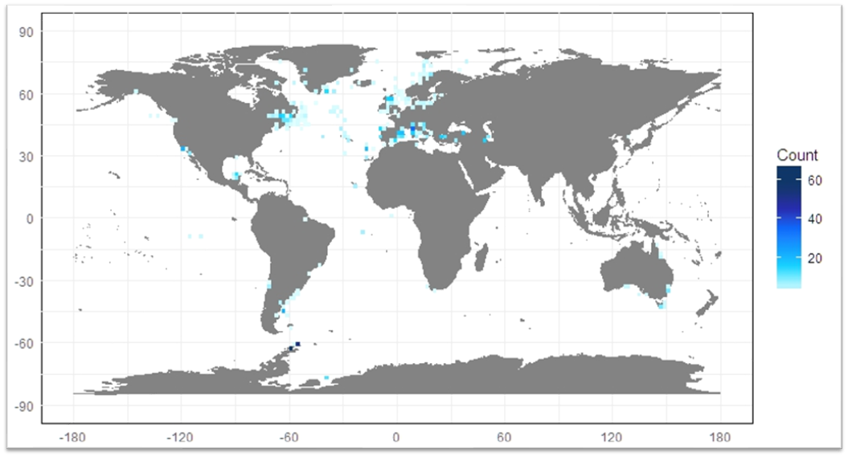

Figure 2: A map of the anisakid records compiled in Fiorenza et al [(Fiorenza et al. 2020)](https://paperpile.com/c/kiyr7b/8fdd).

Without knowing the trends in marine mammal parasite abundance in the ecosystem locally, it is impossible to determine if the observed global increase in anisakids poses a risk to the at-risk marine mammals in the northeast Pacific. Rising rates of *Anisakis* spp. may pose a threat to many marine mammal species, but those whose populations are already declining and facing cumulative stressors could be particularly at risk. The southern resident killer whale (*Orcinus orca*) is a population of piscivorous killer whales that range from British Columbia to Northern California ([Hanson](https://paperpile.com/c/kiyr7b/qEet) 2015). For a cetacean, southern residents are an impressively well-studied species, largely due to their Salish Sea range overlapping with increasingly urban habitats [(Mann et al. 2000)](https://paperpile.com/c/kiyr7b/LfOj). Southern residents have been photo-identified in the Salish Sea since 1973, coinciding with the last years of the selected removal of killer whales for the aquarium trade, making them one of the longest studied cetacean species [(Mann et al. 2000)](https://paperpile.com/c/kiyr7b/LfOj). Unfortunately, due to an increasing number of anthropogenic stressors, SRKWs are still highly threatened due to their urban habitat. The main threats to this population are a shortage of their preferred prey, Chinook salmon (*Oncorhynchus tshawytscha*) and chum salmon (*Oncorhynchus keta*) [(Ford and Ellis 2006)](https://paperpile.com/c/kiyr7b/DlO0); high concentrations of contaminants from major neighboring cities of Seattle, Vancouver, and Victoria [(Krahn et al. 2007)](https://paperpile.com/c/kiyr7b/Aq8S); and vessel noise from small boats and ships in the Salish Sea (Williams et al. 2014; Holt 2008). Due largely in part to these stressors, the population was listed as endangered by the U.S. in 2005, yet the SRKW population has continued to decline; the population is now at 74 whales.

The impacts of sublethal stressors worked synergistically, resulting in the southern resident population in a precarious position on the precipice of extinction [(Lacy et al. 2017)](https://paperpile.com/c/kiyr7b/cy1u). Southern residents, and killer whales in general, have a relatively low growth rate, which leaves them particularly susceptible to stress (Stark et al. 2004). While an individual might be able to withstand the impacts of one sublethal stressor, like a shortage of available prey, when acting in concert with others like contaminants and acoustic stress, the ability to withstand the stressors decreases (Wright 2012; Williams et al. 2016). Currently, modeling the cumulative effects of these known stressors of southern residents results in a projection that the population should be stable [(Lacy et al. 2017)](https://paperpile.com/c/kiyr7b/cy1u). However, these may not be the only sublethal stressors acting upon resident killer whales. In addition, there might be underlying exposure to disease and pathogens. Parasites, when occurring in addition to other anthropogenic or natural stressors, can impact animal health by weakening tolerance or resistance to infections [(Marcogliese and Pietrock 2011)](https://paperpile.com/c/kiyr7b/B1EK). This can lead to a negative feedback loop, in which killer whales undergo stress from multiple anthropogenic factors, leaving them unable to resist infection, which as a result, reduces their condition and leaves them more vulnerable to anthropogenic stress [(Beldomenico and Begon 2010)](https://paperpile.com/c/kiyr7b/n7Xp). Additionally, host characteristics may influence susceptibility to parasite infections, meaning that parasitism may disproportionately affect some members of the population based on age or sex [(Marcogliese and Pietrock 2011)](https://paperpile.com/c/kiyr7b/B1EK). If young whales are particularly susceptible to parasitism, then the southern resident population may not recover at the projected rate [(Lacy et al. 2017)](https://paperpile.com/c/kiyr7b/cy1u). The implications of this were observed in southern residents in 2018.

In August 2018, NOAA researchers determined that a young, female southern resident killer whale known as J50 was undernourished, and supplemental feeding was attempted. While this intervention was underway, researchers collected samples to further diagnose her ailments. They found moderate levels of *Contracaecum* sp., which is treatable with deworming medication, in a scat sample from the group with which she was travelling. With this information in hand, NOAA included an anti-helminthic drug in their treatment plan for J50. If the sample came from her, this was a course of action that would at least reduce the energetic burden demanded by parasites, allowing an emaciated whale to obtain a greater proportion of the energy from the fish they were trying to feed her. At best it could reduce the pathology the parasites were causing by killing any living helminths. However, they lost her before that treatment could be implemented, and she was presumed dead after several days of searching. Recently, the first report of a killer whale with anisakid infection associated with gastritis was published, and it came from a southern resident calf [(Raverty et al. 2020)](https://paperpile.com/c/kiyr7b/gnqH). A 3-year-old southern resident killer whale was found to have 30 *Anisakis simplex* in her fore-stomach mucosa [(Raverty et al. 2020)](https://paperpile.com/c/kiyr7b/gnqH). While anisakids are not known to have resulted in killer whale fatalities, the cases indicate that their health impact, especially on young animals, should not be underestimated.

To conserve southern residents, a better understanding of the environmental prevalence and impact of intestinal parasites on marine mammal health is necessary. That includes determining if these parasites are a new problem or a persistent stressor in the environment, if the prevalence of intestinal parasites in southern residents is and if it is correlated with poor health in living whales, and what the energetic burden of parasites are on their hosts. Without baseline information about the history of southern residents with anisakids and their impact today, parasitism as a sublethal stressor cannot be addressed in the management and conservation of southern residents.

### Objectives

My dissertation research aims to assess whether parasitic threats to marine mammals are greater today than they were in the past, and to understand what this means for marine mammal health and population status. This will be studied directly in one case study of an extremely at-risk marine mammal in the Puget Sound, the southern resident killer whale. My research has five main goals:

1. Determine how the anisakid abundance in key prey species of marine mammals has changed over the past 60 years throughout the world, to assess how the global risk of intestinal nematode parasitism has changed. I will use a meta-analytic dataset compiled by Fiorenza et al. (2020) and animal ranges from the IUCN database and FishBase to determine which prey species have shown a change in anisakid abundance.
2. Determine how the anisakid abundance of key prey species has changed over the past 80 years in Puget Sound, to assess how the risk of intestinal nematode parasitism has changed for this critically endangered host. I will dissect and conduct parasitological analysis of museum specimens of common prey species from the past century to determine how anisakid abundance has changed.
3. Assess how the anisakid abundance of salmon species has changed over the past 40 years in Alaska, to determine what trends in nematode abundance are detectable in a comparable ecosystem. I will dissect canned salmon filets to detect anisakids and determine if there has been an increase in worm abundance per gram of fish over time.
4. Test whether intestinal nematode prevalence is correlated with southern resident killer whale individual body condition by examining individually identified whale fecal samples and photogrammetric imagery. I will extract and examine existing, non-invasively collected scat samples to assess parasite diversity and egg abundances, which will be linked to animal body condition and host health using photogrammetry data.
5. Calculate the proportion of metabolic energy that is abstracted by intestinal nematodes from their marine mammal hosts, using information on parasite intensity and body size from necropsy samples and standard equations of the metabolic theory of ecology. I will dissect the intestinal tract of representative pinniped and cetaceans species to count and measure all parasites present and ultimately calculate the energetic cost to the host.

### Methods

#### Chapter 1

The recent study by Fiorenza et al. (2020) showed that there has been an increase in *Anisakis* spp. worldwide. But what does that mean for marine mammals around the world? What is the trend in fish that marine mammals eat, are these species showing the same trend as the overarching global trend? My first chapter will assess how the global risk of anisakid parasitism has changed for marine mammal hosts from 1980 to present. I used the meta-analytic dataset compiled by Fiorenza et al. (2020) but focused on the fish prey species of marine mammals. I used the IUCN Red List database to obtain the current geographic distribution of every marine mammal species. I obtained diet data cataloged using each marine mammal species’ IUCN summary, and when little information is available, conducted a literature review to determine the common prey species of those marine mammals. When prey species were included to only the family level, I used FishBase to compile every fish of that family that inhabits the marine mammal predator’s range. Then, I filtered the Fiorenza et al. (2020) records to include only those records that fall within both the geographic and the diet range of at least one marine mammal species. I performed a final filter to ensure that the prey species sampled from Fiorenza et al. actually fell within the range of the marine mammal that eats it. Once I obtained the records that overlapped both spatially and geographically, I ran two generalized linear mixed effects models on my subset of the meta-analysis dataset to determine whether there has been a change in anisakid abundance in prey species of marine mammals over time, and if there has been a change in specific marine mammals’ prey species (Table 2). This study will provide an estimate of how the risk of parasitism has changed in marine mammals and could inform future investigations into the role of parasitism as a stressor on these already at-risk populations.

|  |  |  |
| --- | --- | --- |
| **Chapter** | **Question** | **Model** |
| 1 | Has anisakid abundance changed in marine mammal prey species over time? | Anisakid abundance^¼ ~ Std length + Definitive Host*Year + Parasite*Year + (1| Intermediate host/Portion of Body) + (1|FAO)+ (1|Method of Counting) + (1|Paper ID/Sample ID) |
| 1 | Has anisakid abundance changed in each specific marine mammal’s prey species over time? | Anisakid abundance^¼ ~ Std length + Year+ Parasite*Year + (1| Intermediate host/Portion of Body) + (1|FAO)+ (1|Method of Counting) + (1|Paper ID/Sample ID) |
| 2 | How has parasite abundance changed over time in each host species? | Parasite abundance ~ Year of collection + Offset(log of fish standard length) + (1| Site) |
| 3 | How has parasite abundance changed in salmon over time? | Parasite abundance/gram fish ~ Year of collection + Species + (1| Cannery) |
| 4 | What are the effects of population and temporal variables on parasite egg abundance? | Egg count ~ Year + Month + Age + (1|Pod/ID) |
| 4 | What is the effect of the parasite egg abundance on the body condition of an individual? | Body condition ~ Year + Month + Age + Egg count +(1|Pod/ID) |
| 4 | What is the effect of specific parasite species burdens on the body condition of an individual? | Body condition ~ Year + Month + Age + Egg count*Parasite Species +(1|Pod/ID) |

Table 2: Models used for each chapter of my dissertation.

#### Chapter 2

Meta-analysis is an excellent tool for revealing change on the scale of several decades and over a broad spatial range, however it is temporally limited to the 1980s to present day [(Harmon et al. 2019)](https://paperpile.com/c/kiyr7b/JPGJ). This is because most meta-analyses are completed using online literature repositories, and these can incompletely catalogue literature generated before the advent of computing and are biased against null results. Because ocean ecosystems have been changing for hundreds of years, a deeper perspective is useful for understanding long-term change in its historical context [(Lotze and Worm 2009)](https://paperpile.com/c/kiyr7b/EgEc). Museum specimens can provide this deeper perspective, providing a more appropriate baseline to assess ecosystem change [(Harmon et al. 2019)](https://paperpile.com/c/kiyr7b/JPGJ). This is especially useful in assessing the role of parasitism in an endangered marine mammal species like the southern resident killer whale.

SRKW are declining, and if parasites are a stressor, are they a new problem or something that these whales have had for decades? We can assess this by determining how the parasite load we see today in ecologically important prey species compares to what they were in the past. Luckily, this question can be answered with the preserved time capsules housed in museum collections. By dissecting and examining museum specimens of fish species collected over the past century, our lab aimed to determine how parasite assemblages have changed in the Puget Sound as part of a larger investigation into parasites of the past funded by a UW Innovation Award and a Sloan Research Fellowship (Parasites of the Past, or PoP Project). I propose to use this methodology on key prey species of marine mammals, including Pacific herring (*Clupea pallasii*), Pacific hake (*Merluccius productus*), surf smelt (*Hypomesus pretiosus*), striped surfperch (*Embiotoca lateralis*) and walleye pollock (*Gadus chalcogrammus*). Ideally Chinook, coho, or chum salmon (i.e., the main prey species of Southern resident killer whales) would also be sampled, but specimens of these species are not well represented in natural history museums to the level of replication necessary for this analysis. However, these salmon species eat many species of smaller forage fish, including Pacific herring (*Clupea pallasii*), meaning that they are useful proxies for what parasites killer whales have been exposed to [(Daly et al. 2009; Duffy et al. 2010)](https://paperpile.com/c/kiyr7b/UCS3+L4Pe).

I, with the rest of the PoP Project team, dissected a representative sample size of each species of interest, determined by the availability of preserved fish sampled relatively evenly across the 20th century. Our replication was Pacific hake (n = 69), surf smelt (n = 80), walleye pollock (n = 98), striped surfperch (n = 94), and Pacific herring (n = 114), distributed across the range of decades available (Table 3). Specimens were selected from the UW Burke Museum’s Ichthyology collection based on average size and number of fish available per decade. When decades were not well represented, loans from other natural history museums were sourced to fill in data gaps. Only lots that have multiple specimens were included. Each specimen was then dissected and examined under a microscope for parasites both externally and within the internal organs. All parasites found were recorded and vouchered, including nematodes of the family Anisakidae. The internal organs of the fish were collected into a jar and returned to the collection, preserved with the host.

|  |  |  |  |  |  |  |  |  |  |  |  |  |  |  |
| --- | --- | --- | --- | --- | --- | --- | --- | --- | --- | --- | --- | --- | --- | --- |
| **Species** | **1880s** | **1890s** | **1900s** | **1910s** | **1920s** | **1930s** | **1940s** | **1950s** | **1960s** | **1970s** | **1980s** | **1990s** | **2000s** | **2010s** |
| Pacific hake |  |  |  |  |  | 14 | 4 | 1 | 9 | 2 | 14 | 14 |  | 11 |
| Surf smelt | 1 | 1 | 1 |  | 20 | 15 | 16 |  | 15 | 5 | 4 |  |  | 3 |
| Walleye pollock |  |  | 4 |  | 2 | 14 | 14 | 5 | 3 | 12 | 4 | 14 | 12 | 14 |
| Striped surfperch |  |  |  |  | 3 | 14 | 14 | 8 | 17 | 12 | 10 | 5 | 7 | 4 |
| Pacific herring |  | 10 |  |  | 14 | 14 | 5 | 9 | 14 | 10 | 14 | 14 |  | 10 |

Table 3: The number of fish from each decade available for dissection from the UW Burke Museum’s fish collection or alternate fish collections throughout the US.

#### 

#### Chapter 3

While museum specimens can reveal changes in parasite abundance in key forage fish species in Puget Sound, without assessing salmon prey directly, my ability to determine how parasite load has changed in southern residents is limited. Unfortunately, historical salmon samples from the Puget Sound appear to be nonexistent. However, assessing change in other salmon species in the Eastern North Pacific could provide useful insight into the trends of anisakid abundances regionally over time. Recently, our lab found a trove of data that can help us answer this question. The Seafood Products Association (SPA), located in Seattle, is an organization that inspects fish products before sale. They have canned salmon stored in their basement spanning decades. They have generously contributed 475 cans of Alaskan salmon processed between the late 1970s and 2019 to determine how anisakid loads are changing in commercially caught and marketed salmon (Figure 3). Anisakid parasites are easily detectable with the naked eye from processed foods [(Klapper et al. 2018)](https://paperpile.com/c/kiyr7b/BA8o), Figure 4). Because each can has a code that identifies the species of salmon, where the fish was processed, and the year in which processing occurred, they provide a snapshot in space and time of the anisakid load of salmon. I can make use of this novel data source to determine how the risk of anisakid parasite infection changed over time for the marine mammals that consume salmon in that area, which can provide an understanding of the trends that may be occurring further south in the Salish Sea. Additionally, this methodology can be used in future studies if other collections like this are discovered.

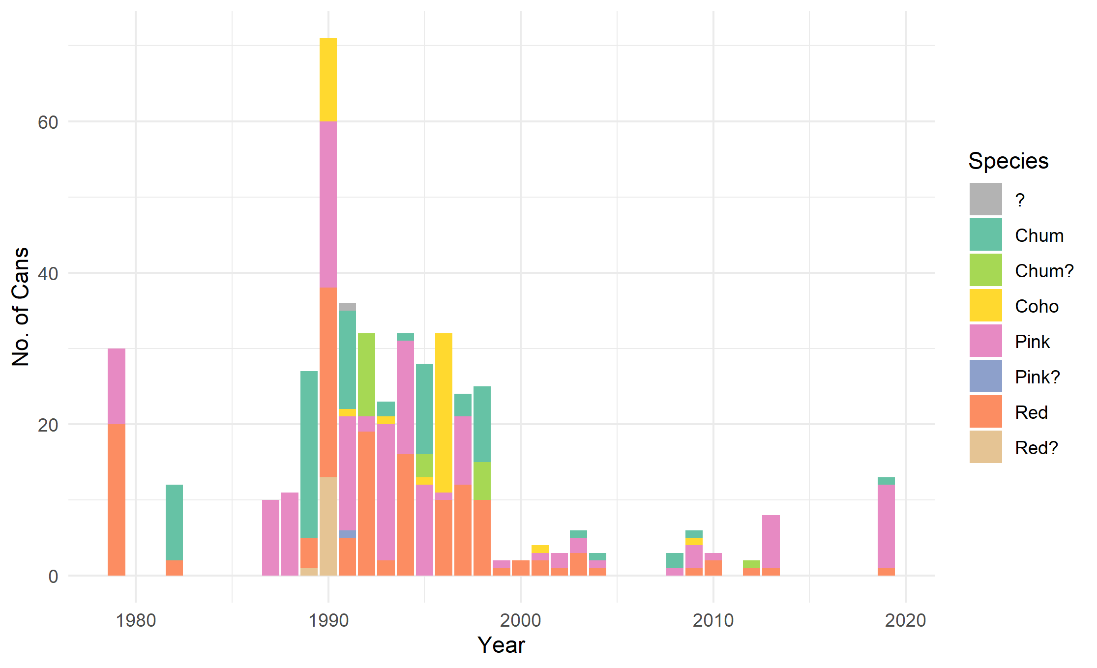

Figure 3: The available cans of salmon procured from SPA. Some can labels wore off over time, resulting in uncertainty about the species in the can (and a question mark by the species). I will be analyzing only a subsample of these cans with certain species identification.

Chinook salmon are the main prey item of southern residents, but they are also a prized fish for commercial harvest. As a result, they are rarely canned (Bruce Odgaard, SPA, personal communication). However, other salmon species contribute to the diet of resident killer whales in Puget Sound and Alaska [(Matkin 2011](https://paperpile.com/c/kiyr7b/z5pI); [Ford and Ellis 2006](https://paperpile.com/c/kiyr7b/DlO0); [Hanson 2015)](https://paperpile.com/c/kiyr7b/qEet). Southern Alaskan resident killer whales are known to eat Coho and Chum [(Matkin 2011)](https://paperpile.com/c/kiyr7b/z5pI), northern residents in British Columbia and the Salish Sea are known to eat Chum, Coho, and pink salmon [(Ford and Ellis 2006)](https://paperpile.com/c/kiyr7b/DlO0), and southern residents consume Coho, Chum, and red salmon [(Hanson 2015)](https://paperpile.com/c/kiyr7b/qEet). Additionally, these other salmon species have comparable life histories, leaving them prone to similar stressors and threats as Chinook (Groot 1991). Therefore, assessing parasite load in other salmon species is worthwhile in determining if anisakid abundances have changed. SPA has contributed cans of Chum (*Oncorhynchus keta)*, pink (*Oncorhynchus gorbuscha)*, and red (*Oncorhynchus nerka*) salmon collected from Alaskan fisheries that I will analyze for changes in anisakid burden.

I, with the help of an undergraduate capstone researcher and a postdoc in our lab, will dissect a representative sample of each species across the four decades. We will sample from well-represented canneries. This is to minimize the noise additional canneries could introduce to the subsequent analysis. Our subsampling resulted in the following sample sizes: pink (n = 65), red (n = 50), chum (n = 35), spread as evenly as possible across decades (Table 4). Some cans are classified as pre-1982 (after which the labelling requirements became standardized across Alaskan canneries), which will be analyzed as their own time period. We will dissect each filet manually with forceps, and carefully extract each nematode, quantifying the number of worms per gram of salmon tissue and identifying each worm to the lowest possible taxonomic level. We will then incorporate the data into a generalized linear mixed model with parasite abundance per gram as the response variable, year and species as fixed effects, and cannery as random effect (Table 2).

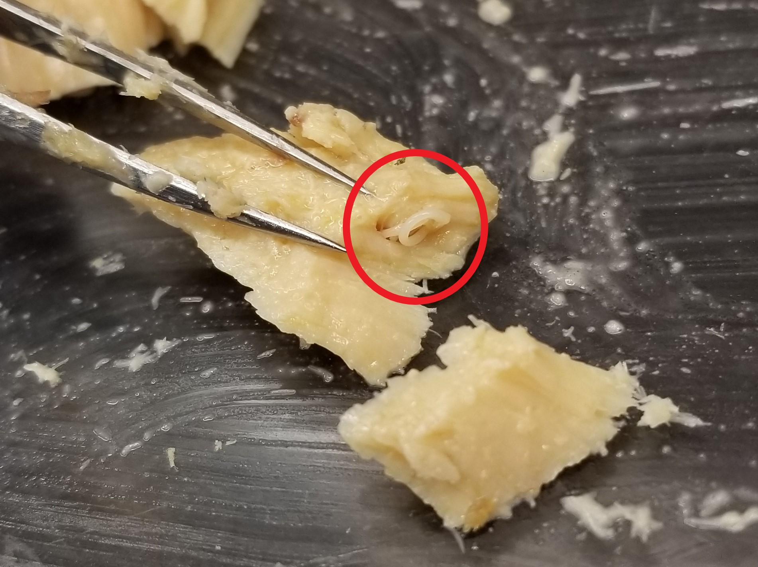

Figure 4: An anisakid nematode found in a filet of canned chum salmon.

|  |  |  |  |  |  |
| --- | --- | --- | --- | --- | --- |
| **Species** | **1970s** | **1980s** | **1990s** | **2000s** | **2010s** |
| Chum | 0 | 16 | 13 | 5 | 1 |
| Pink | 10 | 15 | 15 | 10 | 15 |
| Red | 10 | 6 | 15 | 10 | 5 |

Table 4. The distribution of samples available for each species in each decade, provided by the SPA. This does not include cans classified as “pre-1982”.

#### Chapter 4

Whether the risk of anisakids has increased over time or not, these and other intestinal helminths could represent a threat to the health of marine mammals today. However, little is known about the parasites currently infecting living marine mammals in Puget Sound, especially endangered southern residents. In this chapter, I will assess the parasites found in southern residents using fecal samples from known individuals. I will then compare these parasite loads to the body condition of the whale to determine if infected individuals appear to be nutritionally stressed. I have conducted a thorough review of the existing literature of parasites found in marine mammals and Pacific salmon species to which SRKW may be particularly vulnerable. I have obtained scat samples collected between 2011 and 2019 by NOAA’s Northwest Fisheries Science Center and Dr. Sam Wasser’s lab at UW. In taxonomic identification analysis, I will primarily be looking for macroparasites previously observed to have deleterious effects in marine mammal species, specifically cestodes, acanthocephalans, nematodes, and trematodes, all of which are found in the intestines of both cetaceans and pinnipeds([(Geraci and St. Aubin 1987; Javier Aznar et al. 2001; Greenwood et al. 1979)](https://paperpile.com/c/kiyr7b/4RTx+kkei+RAqh). Each scat sample will be subset into a 0.5g subsample and subjected to a veterinary fecal floatation technique derived by the protocols used by the Marine Mammal Center [(Girard et al. 2016)](https://paperpile.com/c/kiyr7b/sbVq). Two subsamples will be taken for each fecal sample. I will then examine samples under a high-power microscope to identify and count parasite eggs and oocysts. Based on morphometrics, I will identify parasites to the family level and voucher eggs and oocysts of the same morphotype within a small vial containing 95% ethanol. In addition, I will subset a sample of eggs and oocysts from each morphotype identified to be genetically sequenced to identify parasites to the species level and ground truth the fecal sample analyses.

Based on the identification of the parasite eggs in the subset, I will derive the proportion of parasite species in the fecal sample to calculate abundance. These two factors, identification and abundance, will be used to quantify diversity and mean intensity of intestinal parasitism in SRKW. I will run a generalized linear mixed effects model with egg count as response variable and individual and environmental demographics to determine what factors influence parasite abundance (Table 2). I will also determine what proportion of killer whales sampled were infected with each type of parasite, to extrapolate the proportion of the population infected with parasites. To contribute to knowledge on marine mammal parasites in the Puget Sound, I will build a meta-dataset of parasite life history information and add to it as new parasite species are discovered in fecal samples. For each parasite, I will specify the taxonomic affiliations and transmission strategy, if known, to create a database of parasites found in SRKW.

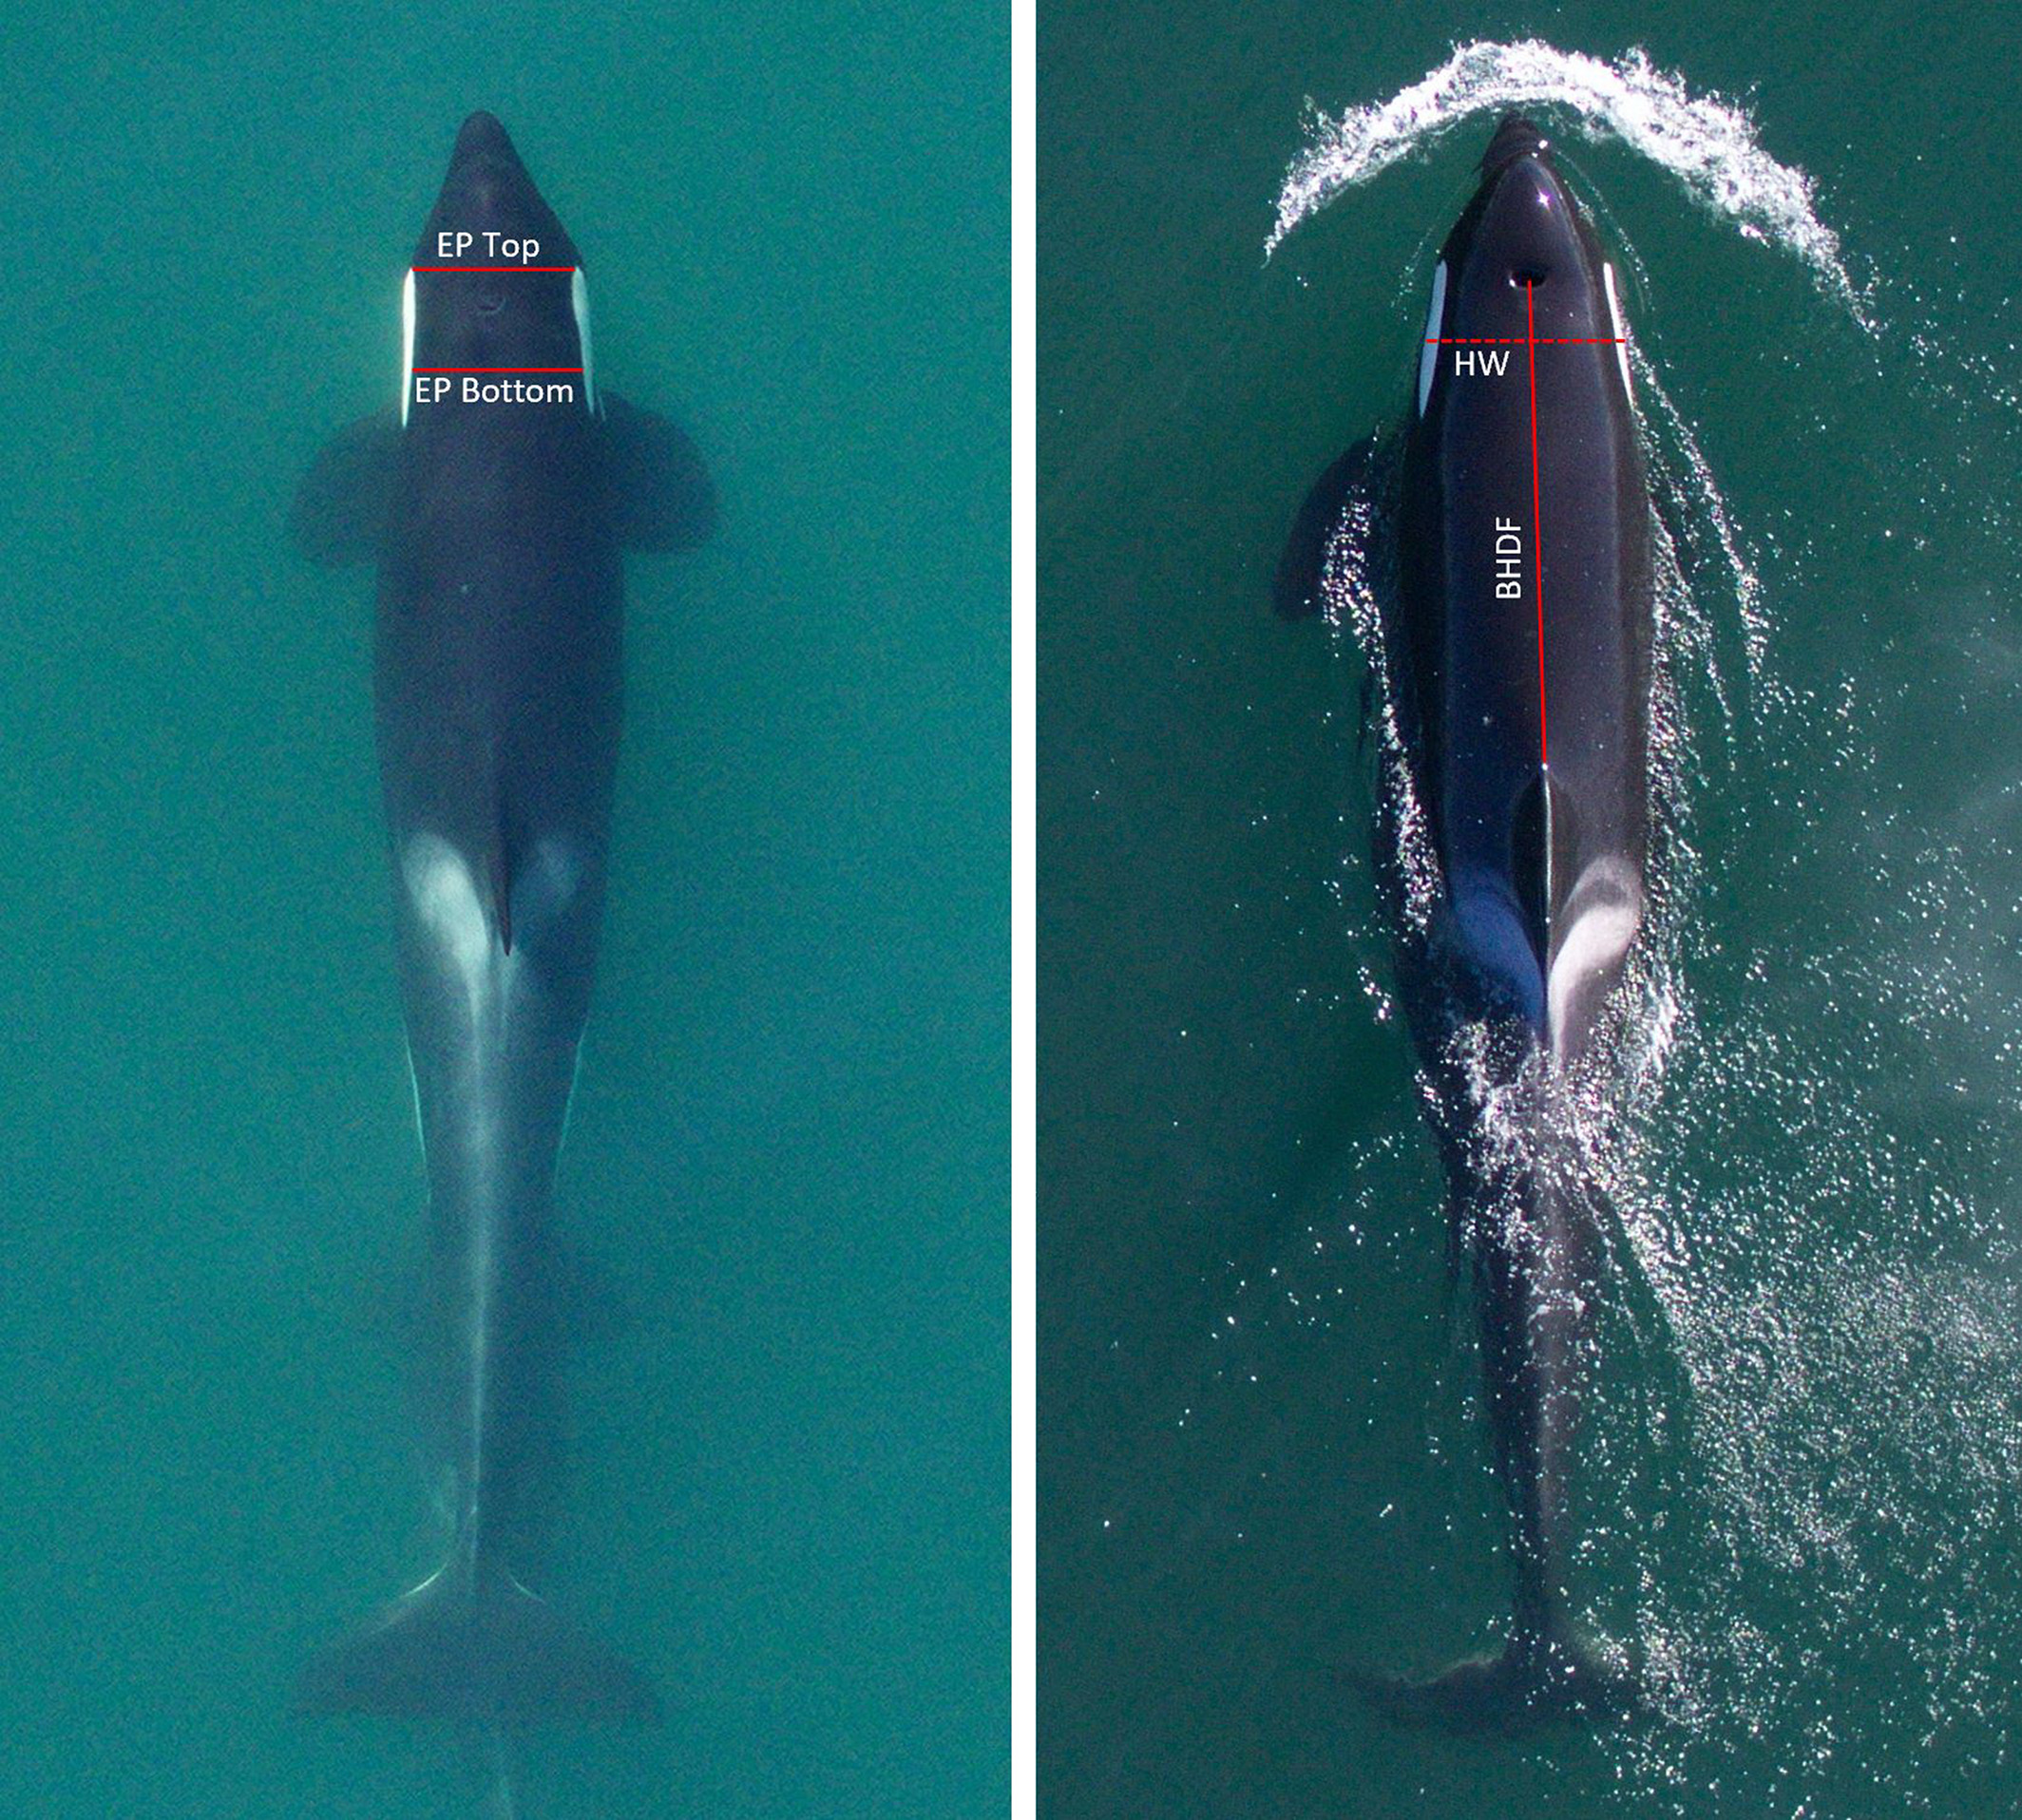

Figure 5: From [(Fearnbach et al. 2020)](https://paperpile.com/c/kiyr7b/RUMK) Photogrammetry measurements taken using aerial photos of whales to assess changes in body condition within individuals.

To determine if there is a correlation with body condition and parasite prevalence and egg abundance, I will use photogrammetry data collected from Dr. Holly Fearnbach and Dr. John Durban during months corresponding to the collected scat samples, when available. Each scat sample has been genetically identified by Dr. Kim Parsons at NWFSC, so that each host is known and can be connected to the appropriate photogrammetry data. Photogrammetry is a commonly used methodology for determining nutritional stress in a killer whale [(Fearnbach et al. 2018, 2020)](https://paperpile.com/c/kiyr7b/4HUg+RUMK). Specific measurements are taken of a whale to assess changes in body condition over time (Figure 5). Animals with a pronounced depression behind their cranium, or “peanut head,” are pronounced nutritionally stressed.

I will compile photogrammetry data collected within a narrow temporal window (within 1 month) of each collected scat sample. I will compare parasite load to body condition measurements from photogrammetry data to determine if there is a significant relationship between the observed body condition of the individual and the parasite load based on the sample season and year using two generalized linear mixed effect models, one for overall egg count and a second incorporating individual parasite taxa (Table 2). This will aid in determining the overall parasite effect on its host and can be used in inferring population health.

#### Chapter 5

Assessing if killer whales are infected with parasites is only one step in determining how these parasites impact their living host. Ultimately, I am interested in understanding whether parasitism represents a significant energetic burden on marine mammal health. This can be achieved using the metabolic theory of ecology, which can be used to estimate the energetic flux of both a parasite and its host by using the mass of the parasite, the temperature of the host, and a suite of other variables and constants found in the literature for well-studied host and parasite species [(Gillooly et al. 2001; Brown et al. 2004)](https://paperpile.com/c/kiyr7b/kFrT+z7dK). The formula for energetic flux is:

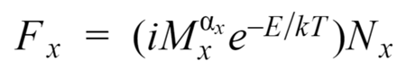

In this equation, *i* is the metabolic normalization constant, *M* is the mass of the individual, is a scaling exponent, generally assumed to be , *E* is the activation energy of metabolism, *T* is the internal temperature of the host, and therefore the parasite, and *N* is the number of individuals [(Gillooly et al. 2001; Brown et al. 2004)](https://paperpile.com/c/kiyr7b/kFrT+z7dK). From finding the energetic flux of both the host and its parasites, the percent energy siphoned by the parasite can be calculated as:

The percent energy siphoned can be used to assess the metabolic cost of parasitism (Hechinger et al. 2014). Metabolic theory research is an emerging direction in parasitology, but it has enormous potential for quantifying the host energy lost to parasites.

To calculate the energy lost due to intestinal parasites for a marine mammal host, I will individually measure and weigh each parasite found in the entirety of a marine mammal’s gastrointestinal tract. This study will take advantage of necropsied animals. I will use samples from two representative and frequently stranded animals: harbor seal and harbor porpoise. While these species are currently neither at risk nor endangered, they are still useful as a proxy for species that are. These samples have been collected from the Washington Department of Fish and Wildlife and the Whale Museum in Friday Harbor. I will use 5-10 gastrointestinal tracts from each species to determine a range of energy siphoned by parasites for each host. When available, I will opportunistically sample other species for comparison, including humpback or gray whales that strand in the area.

Each intestinal tract will be used to determine the species and loads of parasites in Puget Sound, as well as to estimate the percent energy siphoned by parasites. Once intestinal tracts are collected, I will dissect them in the lab, carefully scraping out the entire tract to remove any parasites. Each parasite will be identified using morphometrics, counted, measured, weighed, and vouchered in 95% ethanol. Energy flux is calculated using the formula mentioned above. Table 5 describes where the values I will use for each variable are derived. This will provide a range of estimated energy losses for each species to relate to parasite counts that are commonly recorded in necropsy data, which will inform estimates in historical data and going forward in necropsy.

|  |  |  |
| --- | --- | --- |
| **Variable** | **Description** | **Derived from** |
| Mp | Mass of parasite | Measured in situ |
| Mh | Mass of host | Estimated from age class and sex of necropsied host |
| T | Temperature | Literature of internal pinniped and cetacean temperature |
| N | Number of individuals | Counted for each type of parasite in the GI tract |
| i | Metabolic normalization constant | Literature |
|  | Scaling exponent, generally assumed to be | Literature |
| E | Activation energy of metabolism | Literature (Dell et al. 2011) |

Table 5: The values in MTE energy flux estimates, and what values I plan to use.

In addition to performing the metabolic estimates for the parasites found in the GI tract, I will also use gastrointestinal tracts to assess the relationship between eggs found in the feces towards the rectal portion to adults of the same species in the stomach and intestine. This will better inform the conclusions derived in Chapter 4 and will assist in determining how infected these whales likely are with adult worms. At the rectal portion of the tract, I will collect several 0.5g fecal samples from each individual and perform the fecal floatation methodology used in Chapter 4. I will count the number of eggs in each sample and determine which adult parasite they likely came from through the literature. I will then calculate the variance in parasite eggs found in the fecal samples for each individual and compare this range quantitatively to the number of adult worms found within the intestine itself. This range of estimates will provide a minimum value for the egg to adult nematode ratio, with which to make conservative estimates of marine mammal parasite abundances. This will help quantify the relationship between eggs found in fecal samples and parasite load in the host. It can also be used to estimate the minimum energetic burden of SRKW by comparing the egg to adult ratio, estimating the number of adult parasites in killer whales, and calculating their energy requirements.

### Results

#### Chapter 1

Initially, my research objective in Chapter 1 was to assess how the risk to parasitism by anisakids has changed for endangered marine mammals across the world. I ran this analysis for all IUCN and ESA listed marine mammal species, and there was insufficient overlap in diet species compiled in the meta-dataset. Prey species were grouped by their marine mammal predator, and no single mammal species had a large enough overlap or temporal range in data to determine with confidence that there was a change in anisakid abundance within that species’ prey (Type II error). As a result, all statistical tests resulted in insignificant p-values. Additionally, I presented this research at the World Marine Mammal Conference in December 2019, and most of the inquiries I received from other marine mammal researchers were about the risk to their own study species. To address this, I broadened my sample size and the scope of my analysis. I included all marine mammal species, regardless of conservation status. This increased the scope of inference and the confidence in assessment of risk to a larger number of marine mammals. 106 marine mammals were assessed for range and diet overlap, resulting in 30 that overlapped with the meta-dataset from Fiorenza et al. (2020). There was a total of 17 species that had sufficient sample sizes to determine a trend in anisakids in their specific prey species over time. No single species exhibited a change in anisakid abundance in their prey species over time. However, when all marine mammal host species were grouped and I ran the second model without the interaction (Table 2), there was a significant increase in *Anisakis* spp. in their prey species over time (Figure 6). Interestingly, there was also a significant decrease in the abundance of *Pseudoterranova* spp. in these prey species over time.

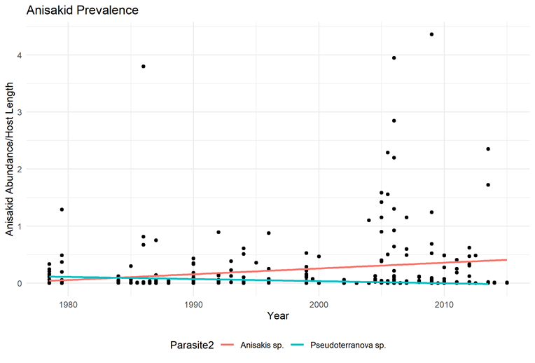

Figure 6: The change in abundance over time for both *Anisakis* spp. and *Pseudoterranova* spp. in the prey species (intermediate hosts) that marine mammals eat.

#### Chapter 2

Dissections for the historical ecology project in Chapter 2 are complete. We have not yet identified the nematodes down to the species level, which is being conducted by a collaborator. Our lab has already discovered interesting changes in overall parasite assemblages over time in English sole (Welicky et al. *in review*), validating our methodology. Preliminary results for hake and herring show a significant increase in anisakid nematodes in Pacific herring and a significant decrease in Pacific hake, but as the parasites have not been identified to the species level, we are unsure if these trends represent *Anisakis* spp. or *Pseudoterranova* spp. (Figure 7). We have also recently completed the dissections of 98 walleye pollock, 80 surf smelt, and 94 striped surfperch, and I will begin analysis on these species in Spring 2021.

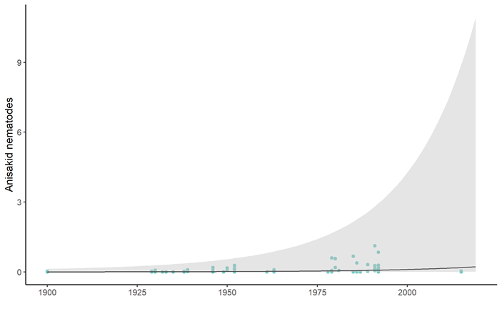

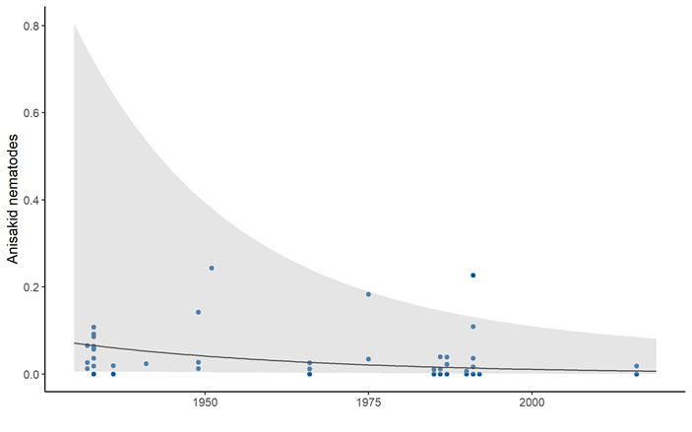

Figure 7: Preliminary trends for anisakid nematodes in Pacific herring (top) and Pacific hake (bottom) over time.

#### Chapter 3

I began communications with SPA in September 2020, and tested methodology fall quarter. As cooked filets appear to not have been assessed for worms in the literature, this involved testing methods that are typically used on fresh or frozen filets, including squishing and UV detection. Once we decided on the appropriate method of dissecting the filet into small pieces by hand, we recruited an enthusiastic undergraduate capstone student in December 2020. We began the data collection portion of this project in January 2021. To date, we have dissected 26 cans, 24 of chum and 2 of pink salmon. There has been a large range in anisakids found per can; the maximum has been 115 worms in a 14.75 oz can. 42.3% of cans so far have had 0 worms, with the remaining 57.7% containing at least one nematode. Based on these preliminary findings, we are optimistic about our method and the detectability in the other species. We aim to have the collection completed in Spring 2021 and data analysis completed by August 2021.

#### Chapter 4

To date, we have performed fecal floats on three SRKW samples. Each has had anisakids present, one with 9 adult nematodes, another with 111 eggs, and the third with over 1000 eggs. This shows that our methodology works, and that parasite eggs are detectable in the frozen samples acquired from different sources. Based on these preliminary findings and background knowledge on the zero-inflated distribution that parasite abundances generally follow, I ran a power analysis to determine how large of a sample size will be needed to detect an effect of egg count on body condition, specifically using the model:

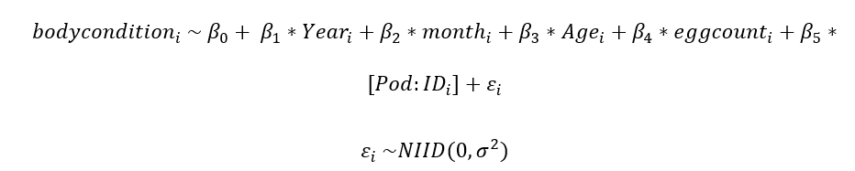

I used a simulated dataset based on SRKW population demographics available from the Orca Networkand preliminary data available. I created a dataset of the IDs, associated pods as a value of 1-3 representing the three pods, and birth years of each individual in the population alive from 2006 to 2018. For each row, I assigned a random year from one of six, representing the 6 years of data I have available. All years have available data from September, but two years had additional samples in May. I assigned a month value of “2” to all other years, and randomly assigned a month value of “1” or “2” for samples from those two years. I subtracted the birth year from the assigned year to get age at sampling and reassigned any negative values to 0. I assigned age classes to each individual, including 1 (calves, 0-4), 2 (subadults, 5-11), 3 (adults, 12-40), and 4 (post-reproductive, 41+). Age class was treated as a factor. I simulated body condition data based on measurements collected by Fearnbach et al. (2018) and assigned measurements based on age class.

I simulated two egg count vectors, one for each model. I used the preliminary data and literature to estimate the distribution of egg counts, which followed a Poisson distribution. I estimated values for beta for each model, listed in Table 2. Based on those values, I generated a random distribution of data to sample from to calculate the egg count for each model. Model 2 used egg counts as a predictor, so egg counts were scaled.

I ran a power analysis to test how many samples would be necessary to detect an effect of egg count on body condition. I used the function powerCurve (simr package, R) which fits the dataset at a range of sample sizes and calculates the frequency of detecting a significant effect. I used the unscaled values for counts and refitted the model, which I ran through powerCurve, analyzing specifically the fixed effect of egg count with ID as the explanatory variable. I also reran the power analysis with a larger β0 value and smaller β values for the rest of the variables, to see how changing the betas influenced the power (β0=4, βID=rnorm(N, 0, 0.1), βmonth=0.1, βyear=0.1, βpod=0.1, βage=(-0.8, 0.1, 0.13, 0.15), βbod=4).

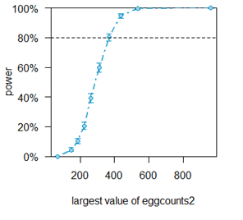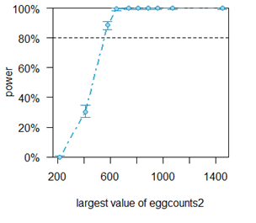

Figure 8: The results of the power analysis for model 2 with the original β values (left), and with altered β values (right).

The power analysis showed that to determine that egg count has an effect on body condition with 80% power, I would need approximately 250 samples. When egg counts exceed 400, the effect is more easily detected (Figure 8). When I reran the power analysis with different betas, 80% was reached at approximately 69 samples. If egg counts are greater, which I will be able to determine when more samples are analyzed, this power will be reached at a lower sample size. By performing more fecal floats, I will be able to better inform this model and get a more accurate estimate of the sample size needed for each population. The samples are available to increase sample size from NWFSC but may not yet be genetically identified to the killer whale it was sampled from, which is necessary for completing Chapter 4. As a result, this chapter will likely be the final chapter completed in my dissertation.

#### Chapter 5

Samples are in hand from 13 adult and one sub-adult harbor seals, and five (as of yet) unknown age class harbor porpoises collected around Washington State from 2019 and 2020. Four of the five harbor porpoise samples are still on site in Friday Harbor, and will be retrieved as soon as quarantine restrictions have lifted on the island. Over the upcoming year (2021), I plan to dissect these intestines and begin quantifying the parasite species abundances and masses to inform my MTE calculations.

### Intellectual Merit

The marine environment is changing, and so are the interactions that occur within it. Marine mammals have generally been increasing, while their prey and parasites have concurrently faced changes in abundance [(Roman et al. 2013; Magera et al. 2013; Fiorenza et al. 2020)](https://paperpile.com/c/kiyr7b/LIhD+lOWZ+8fdd). As mentioned previously, there is evidence that anisakid parasites are increasing in the marine environment, likely due to this increase in marine mammal hosts [(Harvell et al. 2002; Fiorenza et al. 2020)](https://paperpile.com/c/kiyr7b/Cofu+8fdd). This may also be attributable to the generalist nature of anisakids, which makes them particularly adaptable with changing conditions and host availability [(Marcoglise 2002; Klimpel and Palm 2011)](https://paperpile.com/c/kiyr7b/6ecF). Between an increase in marine mammal hosts and an ability to infect a range of intermediate hosts, anisakids might pose a greater threat to definitive hosts than in the past. The trophic mismatches between *Anisakis* sp. and pinnipeds and *Pseudoterranova* sp. and cetaceans are likely to become more frequent, resulting in parasites ending up in the wrong hosts. Strandings like that observed in sea otters in Cordova might be more common. Parasite loads could increase, resulting in more severe pathology than previously observed.

There is a glaring lack of available historical samples from marine mammals with which to detect changes in parasite abundance, and therefore risk, over time. Thus, using new, creative ways to assess how parasitism has changed and what the potential impacts on the host are vitally important to determine how parasite risk to marine mammals is changing [(Harmon et al. 2019)](https://paperpile.com/c/kiyr7b/JPGJ). Advances in historical parasite ecology have generated new methods that can be used to fill in existing data gaps and to assess parasite baselines (Harmon et al. 2019, Howard et al. 2020). My work uses three different historical methodologies: one that is well accepted in the literature, a meta-analysis using published literature; one that is gaining traction, dissections of liquid-preserved fish specimens; and one that is completely novel, dissecting canned salmon filets. These methodologies, especially the latter two, demonstrate the utility of using previously overlooked data to answer questions as to disease risk has changed over time. My dissertation uses these techniques that are on the cutting edge of historical ecology to address previously unanswered questions about the change in risk of parasitism to marine mammals.

The modern methods I am using to assess the prevalence of parasites in southern residents and the potential energetic impact of those loads showcase adaptations of new methodologies and further the knowledge on southern resident killer whale stressors. Southern resident killer whales are an ideal study species because they are well studied. My use of existing samples and collaboration with ongoing projects allows me to directly investigate the parasite egg abundances of individuals with respect to their body condition, which will further our understanding of the impact that parasites play in SRKW health. Additionally, by using MTE to derive the energetic estimates of parasitism on sympatric marine mammal hosts, I will be able to estimate the minimum energetic cost of parasitism. This will provide new information not only on the expense of parasitism on the hosts I sample, but also in estimating the cost in southern residents. This information can be incorporated into population models to assess projected SRKW survival under various future scenarios to determine how the added energetic expense of parasitism could impact endangered whale health in concert with other sublethal stressors.

### Broader Impacts

In marine mammal populations that continue to increase to estimated pre-exploitation levels, increases in acute symptoms from anisakid infections could go unnoticed. However, in populations like SRKW that are struggling to recover and already face a multitude of severe threats, the added burden of increasing anisakid infections might cause a greater impact. Especially given the nutritional stress SRKWs experience with low salmon abundances, an added energy sink in the form of intestinal parasites could conceivably push an already unhealthy animal over the threshold, impacting its survival.

The intervention of J50 marked a shift in management. Before, government agencies were working to conserve a population. The intervention represented an acknowledgement that the conservation status of southern residents has reached a point where each individual in the population matters for the survival of the population itself. Monitoring and protecting the health of individual whales through conservation medical intervention may become more commonplace to prevent an animal from dying.

Individual monitoring is already conducted in SRKW, and the samples needed for this analysis are available as a byproduct of the samples collected for hormone and diet studies. Given that southern resident conservation is now fixed at the level of the individual, including a screening for intestinal parasites will be even more important. My work will quantify how much energy is lost to intestinal parasites in other species in Puget Sound. While this analysis has yet to be performed, I expect that the proportion of energy redirected to parasites in the intestinal tract of marine mammals will be consequential. If medical interventions are to continue, parasites represent a treatable ailment, and my work will be able to provide an estimate of the energy redirected to the individual if treatment is pursued.

Regardless of what my findings suggest, the work I will conduct on the change in anisakid abundance in Puget Sound fish will provide a necessary baseline for future monitoring of both prey species and marine mammal definitive hosts. By determining how anisakid abundance has changed in prey species over the past century and relating these numbers to the change in anisakid abundance found in ten years of SRKW fecal samples, I will be better equipped to estimate how parasite loads have changed in their killer whale definitive hosts. This will provide an important baseline in infection rates that would otherwise be lost to history. My dissertation work will produce both a baseline and present-day monitoring for parasites in southern residents that can inform management and intervention decisions going forward.

### Timeline

My goal in my dissertation is to complete one chapter each year, though with COVID-19, there have been some setbacks. Below is my work plan, which includes projects worked on in the 2018-2019 school year as well as projected work going forward.

|  |  |  |  |  |  |  |  |  |  |  |  |  |  |  |  |  |  |  |  |  |
| --- | --- | --- | --- | --- | --- | --- | --- | --- | --- | --- | --- | --- | --- | --- | --- | --- | --- | --- | --- | --- |
| *Activity* | **2018-2019** | | | | **2019-2020** | | | | **2020-2021** | | | | **2021-2022** | | | | **2022-2023** | | | |
| **Chapter 1** | *F* | *W* | *Sp* | *S* | *F* | *W* | *Sp* | *S* | *F* | *W* | *Sp* | *S* | *F* | *W* | *Sp* | *S* | *F* | *W* | *Sp* | *S* |
| Complete literature review of endangered marine mammal range and diets |  |  |  |  |  |  |  |  |  |  |  |  |  |  |  |  |  |  |  |  |
| Compare for overlap to meta-analysis dataset |  |  |  |  |  |  |  |  |  |  |  |  |  |  |  |  |  |  |  |  |
| Run generalized linear mixed effect model on subset of meta-analysis dataset |  |  |  |  |  |  |  |  |  |  |  |  |  |  |  |  |  |  |  |  |
| Present findings at the World Marine Mammal Conference (Dec 2019) |  |  |  |  |  |  |  |  |  |  |  |  |  |  |  |  |  |  |  |  |
| Write up manuscript |  |  |  |  |  |  |  |  |  |  |  |  |  |  |  |  |  |  |  |  |
| Add additional prey information from every marine mammal species |  |  |  |  |  |  |  |  |  |  |  |  |  |  |  |  |  |  |  |  |
| Re-run analysis |  |  |  |  |  |  |  |  |  |  |  |  |  |  |  |  |  |  |  |  |
| Submit manuscript to [insert journal here] |  |  |  |  |  |  |  |  |  |  |  |  |  |  |  |  |  |  |  |  |
| **Chapter 2** | *F* | *W* | *Sp* | *S* | *F* | *W* | *Sp* | *S* | *F* | *W* | *Sp* | *S* | *F* | *W* | *Sp* | *S* | *F* | *W* | *Sp* | *S* |
| Determine which fish are most ecologically important in Puget Sound for marine mammals |  |  |  |  |  |  |  |  |  |  |  |  |  |  |  |  |  |  |  |  |
| Get trained on historical dissections |  |  |  |  |  |  |  |  |  |  |  |  |  |  |  |  |  |  |  |  |
| Dissect fish from Burke Museum |  |  |  |  |  |  |  |  |  |  |  |  |  |  |  |  |  |  |  |  |
| Start analyzing anisakid data from dissected museum fish |  |  |  |  |  |  |  |  |  |  |  |  |  |  |  |  |  |  |  |  |
| Draft code to add additional fish data to |  |  |  |  |  |  |  |  |  |  |  |  |  |  |  |  |  |  |  |  |
| Write up manuscript when dissections are complete |  |  |  |  |  |  |  |  |  |  |  |  |  |  |  |  |  |  |  |  |
| Submit to [insert journal here] |  |  |  |  |  |  |  |  |  |  |  |  |  |  |  |  |  |  |  |  |
| **Chapter 3** | *F* | *W* | *Sp* | *S* | *F* | *W* | *Sp* | *S* | *F* | *W* | *Sp* | *S* | *F* | *W* | *Sp* | *S* | *F* | *W* | *Sp* | *S* |
| Collect practice cans from SPA |  |  |  |  |  |  |  |  |  |  |  |  |  |  |  |  |  |  |  |  |
| Review literature on parasite detection in fish filets |  |  |  |  |  |  |  |  |  |  |  |  |  |  |  |  |  |  |  |  |
| Test methodologies: Squish, UV light, manual dissection |  |  |  |  |  |  |  |  |  |  |  |  |  |  |  |  |  |  |  |  |
| Collect historical cans from SPA |  |  |  |  |  |  |  |  |  |  |  |  |  |  |  |  |  |  |  |  |
| Recruit capstone student |  |  |  |  |  |  |  |  |  |  |  |  |  |  |  |  |  |  |  |  |
| Train capstone student on dissection methods |  |  |  |  |  |  |  |  |  |  |  |  |  |  |  |  |  |  |  |  |
| Dissect chum, pink, and red salmon cans |  |  |  |  |  |  |  |  |  |  |  |  |  |  |  |  |  |  |  |  |
| Identify parasites to lowest possible level |  |  |  |  |  |  |  |  |  |  |  |  |  |  |  |  |  |  |  |  |
| Analyze data |  |  |  |  |  |  |  |  |  |  |  |  |  |  |  |  |  |  |  |  |
| Present work to ESA 2021 |  |  |  |  |  |  |  |  |  |  |  |  |  |  |  |  |  |  |  |  |
| Write up manuscript |  |  |  |  |  |  |  |  |  |  |  |  |  |  |  |  |  |  |  |  |
| Publish in TBA journal |  |  |  |  |  |  |  |  |  |  |  |  |  |  |  |  |  |  |  |  |
| **Chapter 4** | *F* | *W* | *Sp* | *S* | *F* | *W* | *Sp* | *S* | *F* | *W* | *Sp* | *S* | *F* | *W* | *Sp* | *S* | *F* | *W* | *Sp* | *S* |
| Aid in inventorying fecal samples at NWFSC |  |  |  |  |  |  |  |  |  |  |  |  |  |  |  |  |  |  |  |  |
| Practice fecal floatation methodology on other species |  |  |  |  |  |  |  |  |  |  |  |  |  |  |  |  |  |  |  |  |
| Review literature for commonly found parasite species |  |  |  |  |  |  |  |  |  |  |  |  |  |  |  |  |  |  |  |  |
| Run power analysis on simulated dataset to estimate the number of samples needed |  |  |  |  |  |  |  |  |  |  |  |  |  |  |  |  |  |  |  |  |
| Run paired t-test to determine difference in detectability in fresh vs. frozen samples |  |  |  |  |  |  |  |  |  |  |  |  |  |  |  |  |  |  |  |  |
| Finalize preservation methods for SRKW eggs |  |  |  |  |  |  |  |  |  |  |  |  |  |  |  |  |  |  |  |  |
| Process 18 SRKW fecal samples from NWFSC |  |  |  |  |  |  |  |  |  |  |  |  |  |  |  |  |  |  |  |  |
| Compile ID guide for parasite eggs found |  |  |  |  |  |  |  |  |  |  |  |  |  |  |  |  |  |  |  |  |
| Rerun power analysis using data collected from 18 samples |  |  |  |  |  |  |  |  |  |  |  |  |  |  |  |  |  |  |  |  |
| Request additional samples if needed |  |  |  |  |  |  |  |  |  |  |  |  |  |  |  |  |  |  |  |  |
| Process additional samples |  |  |  |  |  |  |  |  |  |  |  |  |  |  |  |  |  |  |  |  |
| Calculate body metrics for each SRKW sampled |  |  |  |  |  |  |  |  |  |  |  |  |  |  |  |  |  |  |  |  |
| Run analyses relating parasite egg loads to body condition |  |  |  |  |  |  |  |  |  |  |  |  |  |  |  |  |  |  |  |  |
| Run analyses comparing populations |  |  |  |  |  |  |  |  |  |  |  |  |  |  |  |  |  |  |  |  |
| Run analyses for comparing assemblages within individuals |  |  |  |  |  |  |  |  |  |  |  |  |  |  |  |  |  |  |  |  |
| Write up manuscript for Ch 4 |  |  |  |  |  |  |  |  |  |  |  |  |  |  |  |  |  |  |  |  |
| Submit to Marine Mammal Science |  |  |  |  |  |  |  |  |  |  |  |  |  |  |  |  |  |  |  |  |
| Write up report to managers |  |  |  |  |  |  |  |  |  |  |  |  |  |  |  |  |  |  |  |  |
| **Chapter 5** | *F* | *W* | *Sp* | *S* | *F* | *W* | *Sp* | *S* | *F* | *W* | *Sp* | *S* | *F* | *W* | *Sp* | *S* | *F* | *W* | *Sp* | *S* |
| Read background information on MTE |  |  |  |  |  |  |  |  |  |  |  |  |  |  |  |  |  |  |  |  |
| Contact stranding networks |  |  |  |  |  |  |  |  |  |  |  |  |  |  |  |  |  |  |  |  |
| Obtain permit for possession of marine mammal parts |  |  |  |  |  |  |  |  |  |  |  |  |  |  |  |  |  |  |  |  |
| Collect marine mammal intestinal tracts from stranding networks |  |  |  |  |  |  |  |  |  |  |  |  |  |  |  |  |  |  |  |  |
| Procure cetacean samples from the Whale Museum |  |  |  |  |  |  |  |  |  |  |  |  |  |  |  |  |  |  |  |  |
| Complete dissections of existing samples |  |  |  |  |  |  |  |  |  |  |  |  |  |  |  |  |  |  |  |  |
| Calculate relationship between fecal egg abundance and intestinal parasite loads |  |  |  |  |  |  |  |  |  |  |  |  |  |  |  |  |  |  |  |  |
| Begin data analysis for harbor seals and harbor porpoises |  |  |  |  |  |  |  |  |  |  |  |  |  |  |  |  |  |  |  |  |
| Determine best way to scale this relationship to killer whales |  |  |  |  |  |  |  |  |  |  |  |  |  |  |  |  |  |  |  |  |
| Determine if any additional samples are needed |  |  |  |  |  |  |  |  |  |  |  |  |  |  |  |  |  |  |  |  |
| Write up manuscript |  |  |  |  |  |  |  |  |  |  |  |  |  |  |  |  |  |  |  |  |
| Submit to TBD journal |  |  |  |  |  |  |  |  |  |  |  |  |  |  |  |  |  |  |  |  |
| **General PhD Tasks** | *F* | *W* | *Sp* | *S* | *F* | *W* | *Sp* | *S* | *F* | *W* | *Sp* | *S* | *F* | *W* | *Sp* | *S* | *F* | *W* | *Sp* | *S* |
| Reach out to committee members |  |  |  |  |  |  |  |  |  |  |  |  |  |  |  |  |  |  |  |  |
| Finalize committee |  |  |  |  |  |  |  |  |  |  |  |  |  |  |  |  |  |  |  |  |
| Complete dissertation proposal |  |  |  |  |  |  |  |  |  |  |  |  |  |  |  |  |  |  |  |  |
| Read for written exams |  |  |  |  |  |  |  |  |  |  |  |  |  |  |  |  |  |  |  |  |
| Written exams |  |  |  |  |  |  |  |  |  |  |  |  |  |  |  |  |  |  |  |  |
| Oral exam |  |  |  |  |  |  |  |  |  |  |  |  |  |  |  |  |  |  |  |  |
| Write dissertation introduction |  |  |  |  |  |  |  |  |  |  |  |  |  |  |  |  |  |  |  |  |
| Compile dissertation chapters |  |  |  |  |  |  |  |  |  |  |  |  |  |  |  |  |  |  |  |  |
| Write conclusion |  |  |  |  |  |  |  |  |  |  |  |  |  |  |  |  |  |  |  |  |
| Put together presentation |  |  |  |  |  |  |  |  |  |  |  |  |  |  |  |  |  |  |  |  |
| Schedule presentations for the public and managers |  |  |  |  |  |  |  |  |  |  |  |  |  |  |  |  |  |  |  |  |
| Complete Dissertation defense |  |  |  |  |  |  |  |  |  |  |  |  |  |  |  |  |  |  |  |  |

### References

[Aguilar A, Borrell A (1994) Abnormally high polychlorinated biphenyl levels in striped dolphins ( SteneUa coeruleoalba) affected by the 1990-1992 Mediterranean epizootic.](http://paperpile.com/b/kiyr7b/AlJV)

[Anderson RC (2000) Nematode Parasites of Vertebrates: Their Development and Transmission. CABI](http://paperpile.com/b/kiyr7b/bxUa)

Audicana MT, Del Pozo MD, Iglesias R, & Ubeira FM (2003) Anisakis simplex and Pseudoterranova decipiens. FOOD SCIENCE AND TECHNOLOGY-NEW YORK-MARCEL DEKKER-, 613-636

Balbuena JA, Aznar FJ, Fernández M, Raga JA (1995) Parasites as indicators of social structure and stock identity of marine mammals. In: Blix AS, Walløe L, Ulltang Ø (eds) Developments in Marine Biology. Elsevier Science, pp 133–139

Ballachey BE, Gorbics CS, Doroff AM (2002) Sea otter mortality in Orca Inlet, Prince William Sound, Alaska, winter 1995-1996. U.S. Department of the Interior.

[Beldomenico PM, Begon M (2010) Disease spread, susceptibility and infection intensity: vicious circles? Trends Ecol Evol 25:21–27](http://paperpile.com/b/kiyr7b/n7Xp)

Berta A (2020) Return to the Sea: The Life and Evolutionary Times of Marine Mammals. Univ of California Press

[Brown JH, Gillooly JF, Allen AP, et al (2004) Toward a metabolic theory of ecology. Ecology 85:1771–1789](http://paperpile.com/b/kiyr7b/kFrT)

[Bush AO, Lafferty KD, Lotz JM, Shostak AW (1997) Parasitology meets ecology on its own terms: Margolis et al. revisited. J Parasitol 83:575–583](http://paperpile.com/b/kiyr7b/GvMd)

Cassini MH (1999) The evolution of reproductive systems in pinnipeds. Behav Ecol 10:612–616

[Cassoff R, Moore K, McLellan W, et al (2011) Lethal entanglement in baleen whales. Dis Aquat Organ 96:175–185](http://paperpile.com/b/kiyr7b/BwZb)

[Cattan PE, Babero BB, Torres N D (1976) The helminth fauna of CHIle: IV. Nematodes of the genera Anisakis Dujardin, 1845 and Phocanema Myers, 1954 in relation with gastric ulcers in a South American Sea Lion, Otaria byronia. J Wildl Dis 12:511–515](http://paperpile.com/b/kiyr7b/c6RS)

Carlson CJ, Burgio KR, Dougherty ER et al. (2017) Parasite biodiversity faces extinction and redistribution in a changing climate. Science advances, 3(9), e1602422.

Clapham PJ (2018) Humpback Whale: Megaptera novaeangliae. In: Würsig B, Thewissen JGM, Kovacs KM (eds) Encyclopedia of Marine Mammals (Third Edition). Academic Press, pp 489–492

[Combes C (2001) Parasitism: The Ecology and Evolution of Intimate Interactions. University of Chicago Press](http://paperpile.com/b/kiyr7b/Iqxv)

Dailey MD and Gilmartin WG (1980) Diagnostic key to the parasites of some marine mammals. NOSC Technical document 295.

[Dailey MD (2001) Parasitic Diseases. In: CRC Handbook of Marine Mammal Medicine.](http://paperpile.com/b/kiyr7b/IfxJ) <https://www.taylorfrancis.com/.> [Accessed 13 Nov 2019](http://paperpile.com/b/kiyr7b/IfxJ)

[Dailey M, Stroud R (10/1978) PARASITES AND ASSOCIATED PATHOLOGY OBSERVED IN CETACEANS STRANDED ALONG THE OREGON COAST. J Wildl Dis 14:503–511](http://paperpile.com/b/kiyr7b/AC1I)

[Daly EA, Brodeur RD, Weitkamp LA (2009) Ontogenetic Shifts in Diets of Juvenile and Subadult Coho and Chinook Salmon in Coastal Marine Waters: Important for Marine Survival? Trans Am Fish Soc 138:1420–1438](http://paperpile.com/b/kiyr7b/L4Pe)

[Duffy EJ, Beauchamp DA, Sweeting RM, et al (2010) Ontogenetic Diet Shifts of Juvenile Chinook Salmon in Nearshore and Offshore Habitats of Puget Sound. Trans Am Fish Soc 139:803–823](http://paperpile.com/b/kiyr7b/UCS3)

Dunn RR, Harris NC, Colwell RK, et al (2009) The sixth mass coextinction: are most endangered species parasites and mutualists? Proc Biol Sci 276:3037–3045

[Fearnbach H, Durban JW, Barrett‐Lennard LG, et al (2020) Evaluating the power of photogrammetry for monitoring killer whale body condition. Mar Mamm Sci 36:359–364](http://paperpile.com/b/kiyr7b/RUMK)

[Fearnbach H, Durban JW, Ellifrit DK, Balcomb KC (2018) Using aerial photogrammetry to detect changes in body condition of endangered southern resident killer whales. Endanger Species Res 35:175–180](http://paperpile.com/b/kiyr7b/4HUg)

[Fiorenza EA, Wendt CA, Dobkowski KA, et al (2020) It’s a wormy world: Meta-analysis reveals several decades of change in the global abundance of the parasitic nematodes Anisakis spp. and Pseudoterranova spp. in marine fishes and invertebrates. Glob Chang Biol 26:2854–2866](http://paperpile.com/b/kiyr7b/8fdd)

[Ford JKB, Ellis GM (2006) Selective foraging by fish-eating killer whales Orcinus orca in British Columbia. Mar Ecol Prog Ser 316:185–199](http://paperpile.com/b/kiyr7b/DlO0)

[Gambell R (1993) International Management of Whales and Whaling: An Historical Review of the Regulation of Commercial and Aboriginal Subsistence Whaling. Arctic 46:97–107](http://paperpile.com/b/kiyr7b/2lT4)

Gaydos JK, Balcomb KC, Osborne RW, Dierauf L (2004) Evaluating potential infectious disease threats for southern resident killer whales, Orcinus orca: a model for endangered species. Biol Conserv 117:253–262

[Geraci JR, St. Aubin DJ (1987) EFFECTS OF PARASITES ON MARINE MAMMALS](http://paperpile.com/b/kiyr7b/4RTx). International journal for parasitology.

[Gillooly JF, Brown JH, West GB, et al (2001) Effects of size and temperature on metabolic rate. Science 293:2248–2251](http://paperpile.com/b/kiyr7b/z7dK)

[Girard YA, Johnson CK, Fritz HM, et al (2016) Detection and characterization of diverse coccidian protozoa shed by California sea lions. Int J Parasitol Parasites Wildl 5:5–16](http://paperpile.com/b/kiyr7b/sbVq)

[Greenwood AG, Taylor DC, Gauckler A (1979) Odontocete parasites: some new host records. Aquat Mamm 7:23–25](http://paperpile.com/b/kiyr7b/RAqh)

Groot G (1991) Pacific Salmon Life Histories. UBC Press

[Gulland FMD, Hall AJ (2007) Is Marine Mammal Health Deteriorating? Trends in the Global Reporting of Marine Mammal Disease. Ecohealth 4:135–150](http://paperpile.com/b/kiyr7b/RrYy)

[Hanson B (2015) Distribution and Diet of Southern Resident Killer Whales](http://paperpile.com/b/kiyr7b/qEet)

[Harmon A, Littlewood DTJ, Wood CL (2019) Parasites lost: using natural history collections to track disease change across deep time. Front Ecol Environ 17:157–166](http://paperpile.com/b/kiyr7b/JPGJ)

[Harvell CD, Mitchell CE, Ward JR, et al (2002) Climate warming and disease risks for terrestrial and marine biota. Science 296:2158–2162](http://paperpile.com/b/kiyr7b/Cofu)

Hechinger RF (2013) A metabolic and body-size scaling framework for parasite within-host abundance, biomass, and energy flux. Am Nat 182:234–248

Holt MM (2008) Sound exposure and Southern Resident killer whales (Orcinus orca): A review of current knowledge and data gaps.

[Hermosilla C, Hirzmann J, Silva LMR, et al (2018) Gastrointestinal Parasites and Bacteria in Free-Living South American Sea Lions (Otaria flavescens) in Chilean Comau Fjord and New Host Record of a Diphyllobothrium scoticum-Like Cestode. Frontiers in Marine Science 5:459](http://paperpile.com/b/kiyr7b/KXxd)

[Iñiguez AM, Carvalho VL, Motta MRA, et al (2011) Genetic analysis of Anisakis typica (Nematoda: Anisakidae) from cetaceans of the northeast coast of Brazil: new data on its definitive hosts. Vet Parasitol 178:293–299](http://paperpile.com/b/kiyr7b/up1h)

[Javier Aznar F, Balbuena JA, Fernández M, Antonio Raga J (2001) Living together: the parasites of marine mammals1](http://paperpile.com/b/kiyr7b/kkei)

Johnson CM, Norris KS (1986) Delphinid social organization and social behavior. Dolphin cognition and behavior: A comparative approach 335–346

[Klapper R, Carballeda-Sangiao N, Kuhn T, et al (2018) Anisakid infection levels in fresh and canned cod liver: Significant reduction through liver surface layer removal. Food Control 92:17–24](http://paperpile.com/b/kiyr7b/BA8o)

[Klimpel S, Palm HW (2011) Anisakid Nematode (Ascaridoidea) Life Cycles and Distribution: Increasing Zoonotic Potential in the Time of Climate Change? In: Mehlhorn H (ed) Progress in Parasitology. Springer Berlin Heidelberg, Berlin, Heidelberg, pp 201–222](http://paperpile.com/b/kiyr7b/6ecF)

[Klimpel S, Rückert S (2005) Life cycle strategy of Hysterothylacium aduncum to become the most abundant anisakid fish nematode in the North Sea. Parasitol Res 97:141–149](http://paperpile.com/b/kiyr7b/uzXU)

[Klöser H, Plötz J, Palm H, et al (1992) Adjustment of anisakid nematode life cycles to the high Antarctic food web as shown by Contracaecum radiatum and C. osculatum in the Weddell Sea. Antarct Sci](http://paperpile.com/b/kiyr7b/w9n9)

[Knowlton AR, Hamilton PK, Marx MK, et al (2012) Monitoring North Atlantic right whale Eubalaena glacialis entanglement rates: a 30 yr retrospective. Mar Ecol Prog Ser 466:293–302](http://paperpile.com/b/kiyr7b/GYQ5)

[Køie M, Berland B, Burt MDB (1995) Development to third-stage larvae occurs in the eggs of Anisakis simplex and Pseudotetranova decipiens (Nematoda, Ascaridoidea, Anisakidae). Can J Fish Aquat Sci 52:134–139](http://paperpile.com/b/kiyr7b/nnSF)

[Køie M, Fagerholm HP (1995) The life cycle of Contracaecum osculatum (Rudolphi, 1802) sensu stricto (Nematoda, Ascaridoidea, Anisakidae) in view of experimental infections. Parasitol Res 81:481–489](http://paperpile.com/b/kiyr7b/gbKr)

[Krahn MM, Hanson MB, Baird RW, et al (2007) Persistent organic pollutants and stable isotopes in biopsy samples (2004/2006) from Southern Resident killer whales. Mar Pollut Bull 54:1903–1911](http://paperpile.com/b/kiyr7b/Aq8S)

[Lacy RC, Williams R, Ashe E, et al (2017) Evaluating anthropogenic threats to endangered killer whales to inform effective recovery plans. Sci Rep 7:1–12](http://paperpile.com/b/kiyr7b/cy1u)

[Lair S, Measures LN, Martineau D (2016) Pathologic Findings and Trends in Mortality in the Beluga (Delphinapterus leucas) Population of the St Lawrence Estuary, Quebec, Canada, From 1983 to 2012. Vet Pathol 53:22–36](http://paperpile.com/b/kiyr7b/IHnu)

[Laist DW, Knowlton AR, Mead JG, et al (2001) Collisions Between Ships and Whales. Mar Mamm Sci 17:35–75](http://paperpile.com/b/kiyr7b/nnWl)

Lavigne DM, Schmitz OJ (1990) Global warming and increasing population densities: a prescription for seal plagues. Mar Pollut Bull 21:280–284

[Lotze HK, Coll M, Magera AM, et al (2011) Recovery of marine animal populations and ecosystems. Trends Ecol Evol 26:595–605](http://paperpile.com/b/kiyr7b/QIHX)

[Lotze HK, Worm B (2009) Historical baselines for large marine animals. Trends Ecol Evol 24:254–262](http://paperpile.com/b/kiyr7b/EgEc)

[Magera AM, Mills Flemming JE, Kaschner K, et al (2013) Recovery trends in marine mammal populations. PLoS One 8:e77908](http://paperpile.com/b/kiyr7b/LIhD)

[Mann J, Connor RC, Tyack PL, Whitehead H (2000) Cetacean Societies: Field Studies of Dolphins and Whales. University of Chicago Press](http://paperpile.com/b/kiyr7b/LfOj)

Marcogliese DJ (2002) Food webs and the transmission of parasites to marine fish. Parasitology 124 Suppl:S83–99

[Marcogliese DJ, Pietrock M (2011) Combined effects of parasites and contaminants on animal health: parasites do matter. Trends Parasitol 27:123–130](http://paperpile.com/b/kiyr7b/B1EK)

[Margolis L, Dailey MD (1972) Revised annotated list of parasites from sea mammals caught off the west coast of North America. NOAA tech rep NMFS SSRF 647:1–23](http://paperpile.com/b/kiyr7b/Bzrw)

[Margolis L, Groff JM, Johnson SC, et al (1997) Helminth Parasites of Sea Otters (Enhydra lutris} from Prince William Sound, Alaska: Comparisons with Other Populations of Sea Otters and Comments on the Origin of Their Parasites](http://paperpile.com/b/kiyr7b/Yf8F)

[Matkin ESC FORAGING STRATEGIES OF SYMPATRIC KILLER WHALE (ORCINUS ORCA) POPULATIONS IN PRINCE WILLIAM SOUND, ALASKA](http://paperpile.com/b/kiyr7b/z5pI)

[Mattiucci S, Nascetti G (2007) Genetic diversity and infection levels of anisakid nematodes parasitic in fish and marine mammals from Boreal and Austral hemispheres. Vet Parasitol 148:43–57](http://paperpile.com/b/kiyr7b/DAXs)

[McClelland, G (2005) Nematoda (Roundworms). Marine Parasitology](http://paperpile.com/b/kiyr7b/9TXZ)

[McClelland G (2002) The trouble with sealworms (Pseudoterranova decipiens species complex, Nematoda): a review. Parasitology; Cambridge 124:S183–203](http://paperpile.com/b/kiyr7b/4b5F)

MOELLER, RB (2001) Diseases of Marine Mammals. California Animal. Health and Food Safety Laboratory System, California, EUA, 34p.

[Motta MRA, Pinheiro DCSN, Carvalho VL, et al (2008) Gastric lesions associated with the presence of Anisakis spp. Dujardin, 1845 (Nematoda: Anisakidae) in Cetaceans stranded on the coast of Ceara, Brazil. Biota Neotrop 8:0–0](http://paperpile.com/b/kiyr7b/wl18)

Musick JA (1999) Life in the Slow Lane: Ecology and Conservation of Long-Lived Marine Animals. American Fsheries Society Symposium 23. American Fisheries Society, Bethesda, Maryland, USA

NOAA (2016) “Southern Resident Killer Whales (Orcinus Orca) 5-Year Review : Summary and Evaluation.” https://repository.library.noaa.gov/view/noaa/17031.

[Palm HW (1999) Ecology of Pseudoterranova decipiens (Krabbe, 1878) (Nematoda : Anisakidae) from Antarctic waters. Parasitol Res 85:638–646](http://paperpile.com/b/kiyr7b/WzBr)

[Palm HW, Klimpel S (2007) Evolution of parasitic life in the ocean. Trends Parasitol 23:10–12](http://paperpile.com/b/kiyr7b/2U2b)

[Raverty S, St. Leger J, Noren DP, et al (2020) Pathology findings and correlation with body condition index in stranded killer whales (Orcinus orca) in the northeastern Pacific and Hawaii from 2004 to 2013. PLoS One 15:e0242505](http://paperpile.com/b/kiyr7b/gnqH)

[Rohr JR, Civitello DJ, Halliday FW, et al (2020) Towards common ground in the biodiversity-disease debate. Nat Ecol Evol 4:24–33](http://paperpile.com/b/kiyr7b/0RzN)

[Rohr JR, Dobson AP, Johnson PTJ, et al (2011) Frontiers in climate change-disease research. Trends Ecol Evol 26:270–277](http://paperpile.com/b/kiyr7b/8RmI)

[Roman J, Altman I, Dunphy-Daly MM, et al (2013) The Marine Mammal Protection Act at 40: status, recovery, and future of U.S. marine mammals. Ann N Y Acad Sci 1286:29–49](http://paperpile.com/b/kiyr7b/lOWZ)

[Salkeld DJ, Padgett KA, Jones JH (2013) A meta-analysis suggesting that the relationship between biodiversity and risk of zoonotic pathogen transmission is idiosyncratic. Ecol Lett 16:679–686](http://paperpile.com/b/kiyr7b/cFbb)

Stewart BS, DeLong RL (1995) Double Migrations of the Northern Elephant Seal, Mirounga angustirostris. J Mammal 76:196–205

[Stroud RK, Roffe TJ (1979) Causes of death in marine mammals stranded along the Oregon coast. J Wildl Dis 15:91–97](http://paperpile.com/b/kiyr7b/3AFH)

[Ten Doeschate MTI, IJsseldijk LL, Hiemstra S, et al (2017) Quantifying parasite presence in relation to biological parameters of harbour porpoises Phocoena phocoena stranded on the Dutch coast. Dis Aquat Organ 127:49–56](http://paperpile.com/b/kiyr7b/iG3m)

[Trumble SJ, Robinson EM, Berman-Kowalewski M, et al (2013) Blue whale earplug reveals lifetime contaminant exposure and hormone profiles. Proceedings of the National Academy of Sciences 110:16922–16926](http://paperpile.com/b/kiyr7b/Ut3F)

Tyack P (1986) Population biology, social behavior and communication in whales and dolphins. Trends Ecol Evol 1:144–150

US MMPA (1972) 16 U.S. Code CHAPTER 31—MARINE MAMMAL PROTECTION

[van Beurden SJ, IJsseldijk LL, Cremers HJWM, et al (2015) Anisakis spp. induced granulomatous dermatitis in a harbour porpoise Phocoena phocoena and a bottlenose dolphin Tursiops truncatus. Dis Aquat Organ 112:257–263](http://paperpile.com/b/kiyr7b/BjkD)

[Van Bressem M-F, Raga JA, Di Guardo G, et al (2009) Emerging infectious diseases in cetaceans worldwide and the possible role of environmental stressors. Dis Aquat Organ 86:143–157](http://paperpile.com/b/kiyr7b/710b)

[Ward JR, Lafferty KD (2004) The elusive baseline of marine disease: are diseases in ocean ecosystems increasing? PLoS Biol 2:E120](http://paperpile.com/b/kiyr7b/DDpM)

Welicky RL, Pressier W, Fiorenza E et al. (*In review*) Parasites of the past: Eighty-nine years of change in parasite abundance of English sole (Parophyrs vetulus) of Puget Sound, USA. Global Change Biology.

Williams R, Clark CW, Ponirakis D, Ashe E (2014) Acoustic quality of critical habitats for three threatened whale populations. Animal conservation. Apr;17(2):174-85.

Williams R, Thomas L, Ashe E, et al (2016) Gauging allowable harm limits to cumulative, sub-lethal effects of human activities on wildlife: A case-study approach using two whale populations. Mar Policy 70:58–64

[Wood CL, Lafferty KD (2013) Biodiversity and disease: a synthesis of ecological perspectives on Lyme disease transmission. Trends Ecol Evol 28:239–247](http://paperpile.com/b/kiyr7b/gtLT)

Wright AJ (2012) Noise-Related Stress and Cumulative Impact Assessment. In: The Effects of Noise on Aquatic Life. Springer New York, pp 541–543

[Würsig B, Perrin WF, Thewissen JGM (2009) Encyclopedia of Marine Mammals. Academic Press](http://paperpile.com/b/kiyr7b/HweG)